PV CAMPER

Annual Report

30 December 2020



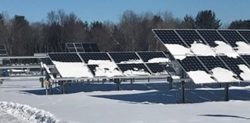

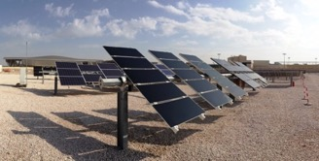

 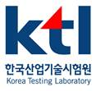   

*Bildergebnis für hochschule anhalt Horizontal_fundo_claro   *

SAND2021-2710 R

LETTER FROM THE CHAIR

Dear Readers,

At a conference four years ago in South Korea, my colleagues and I had a vision: to create an organization of research institutions committed to advancing photovoltaic (PV) research on a global scale. We saw an opportunity to build a *de facto* network of our respective PV field sites and form a community of scientists committed to quantifying and comparing the performance of PV technologies across climate zones. Many meetings, negotiations and conversations later, our vision for such an organization is now a reality. As described here, in our first annual report, the Photovoltaic Collaborative to Advance Multi-Climate Performance and Energy Research—better known as PV CAMPER—is a formally recognized organization, with stringent requirements for membership and a set of by-laws to ensure organizational structure and continuity.

I am proud to say that PV CAMPER has already had significant impact on the solar sector, both as a research organization and catalyst for change. Our ten member institutions, representing a total of 13 field sites, have spawned five research projects, as well as numerous talks and workshops. But numbers alone do not describe our success: PV CAMPER has reached this point because of its dedicated members, all of whom have worked hard to ensure technical excellence across multiple fronts, from sharing best practices for performance monitoring to proposing and leading multi-institutional research projects.

As our organization matures, we look forward to expanding our impact and to jointly tackling a plethora of research challenges in such critical areas as measurement uncertainty, predictive modeling, and the cross-climate reliability of emerging technologies. To that end, we also look forward to expanding our membership and collective expertise.

It has been a privilege to serve as PV CAMPER’s founding chair and I express deep gratitude to my PV CAMPER colleagues, who are a constant source of inspiration and support; and to Lenny Tinker, my program manager in the US Department of Energy’s Solar Energies Technology Office, who has believed in this endeavor from the beginning. Finally, I welcome my successor, Ralph Gottschalg, who was elected PV CAMPER chair for 2021, pleased and honored that he has agreed to steer our organization through the coming year.

Laurie Burnham

Sandia National Laboratories

CONTRIBUTORS TO THIS REPORT

Laurie Burnham

**Sandia National Laboratories**

Ralph Gottschalg

**Fraunhofer CSP**

Sebastian Dittmann

**Anhalt University of Applied Sciences**

Ricardo Rüther

Marília Braga

Aline Kirsten Vidal de Oliveira

**Universidade Federal de Santa Catarina (UFSC)**

Soo-Young Oh

**Yeungnam Universty**

Ben Figgis

**Qatar Environmental and Energy Institute (QEERI)**

Ahmed Benlarbi

**Institut de Recherche en Energie Solaire et Energies Nouvelles (IRESEN)**

Thomas Reindl

Carlos Rodríguez-Gallegos

**Solar Energy Research Institute of Singapore (SERIS)**

Tom Betts

**Loughborough Univerty’s Centre for Renewable Energy Systems Technology (CREST)**

Jun-Hong Choi

**Korea Testing Lab (KTL)**

    

*Bildergebnis für hochschule anhalt Horizontal_fundo_claro   *

# PART I. PV CAMPER

The Photovoltaic Collaborative to Advance Multi-climate Performance and Energy Research, or PV CAMPER, was founded in 2020 to promote collaborative cross-climate photovoltaic (PV) research and help accelerate the world’s transition to a solar-intensive (and solar-reliable) economy. With 10 inaugural members representing a global network of research institutions,

PV CAMPER provides a structured environment for sharing best practices and validation methods, maintains a central repository of performance data, supports the cross-climate validation of emerging technologies, and facilitates collaborations among researchers and institutions worldwide.

PART II. MAJOR GOALS AND OBJECTIVES

The primary objectives of the PhotovoltaicCollaborative to Advance Multi-climate and Performance Research (PVCAMPER) are to:

* Build and maintain a multi-climate, expandable research platform to enable globally relevant photovoltaic research
* Create a trusted environment for data- and information-sharing, including best practices, as well as early indicators of widespread problems
* Validate the performance of emerging technologies across major climatic regions
* Reduce measurement uncertainty and ensure technical excellence across multiple sites, initiatives and platforms
* Identify opportunities for increasing the efficiency—and also the reliability—of PV systems in specific climates

In this reporting period, we:

1. Created a PV CAMPER database on the DuraMAT datahub: datahubhttps://datahub.duramat.org/project/about/pvcamper
2. Executed the PV CAMPER MOU, signed by 100 percent of member institutions
3. Launched four collaborative research projects
4. Created an Associate Member category for industry members
5. Published IEEE PVSC and EU PVSEC conference papers; and presented a paper at the Solar Energy Brazilian Conference (CBENS).
6. Hosted a virtual workshop at PVSEC-30.
7. Elected an Executive Committee to oversee the governance of PV CAMPER.

PART III. PROJECT RESULTS

**Formation of the Collaborative**

The PV CAMPER collaborative is defined by its Memorandum-of-Understanding (MOU) and two-tiered membership structure. Eligibility criteria for primary membership include the institution’s technical capabilities, international reputation, climatic profile and perceived value to researchers and industry.The associate membership category includes 1) research institutions that do not meet the full eligibility requirements but want to contribute data to a particular research project(s) and 2) industry members that make direct contributions to PV CAMPER in the form of equipment and/or funding.

**PV CAMPER Membership**

  
Figure 1. Global distribution of PV CAMPER members

PV CAMPER has 10 founding members, depicted in Figure 1, with the recent addition of the University of Loughborough in England.

**Organizational Framework**

PV CAMPER’s MOU, which defines the roles and responsibilities of primary member organizations, has been signed by the full roster of PV CAMPER member institutions. The breakthrough can be attributed to legal counsel at Sandia and Fraunhofer who finally approved the MOU with the *proviso* that the document be signed by their American subsidiary as follows: “Fraunhofer USA, Inc., a research & development 501(c)3 nonprofit, incorporated in Rhode Island, on behalf of Fraunhofer Center for Silicon Photovoltaics CSP, with its principal location in Halle, Germany.”

The document has now been signed by all member institutions and is therefore considered fully executed.

Table 1. List of PV CAMPER members who have signed the MOU.

|  |  |
| --- | --- |
| **Member Institution** | **MOU** |
| Anhalt University of Applied Sciences (Anhalt) | **X** |
| Fraunhofer CSP | **X** |
| Institut de Recherche en Energie Solaire et Energies Nouvelles (IRESEN) | **X** |
| Korea Testing Lab (KTL) | **X** |
| Qatar Environmental and Energy Institute (QEERI) | **X** |
| Sandia National Laboratories (Sandia) | **X** |
| Solar Energy Research Institute of Singapore (SERIS) | **X** |
| Yeungnam University (YU) | **X** |
| Universidade Federal de Santa Catarina (UFSC) | **X** |
| University of Loughborough (LU) | **X** |

**Data-sharing and analysis**

A primary organizational objective for PV CAMPER is to share comparable data across its global network of field sites generated by common instrumentation and a shared commitment to data quality and reliability.

**Technical Inventory**

Anhalt University of Applied Sciences (Anhalt) has completed a technical inventory of instrumentation and onsite capabilities for all member institutions. Yet to be resolved, however, is the PV CAMPER baseline PV system, which would allow for better comparisons of performance measurements between measurements among all test sites for the different ongoing studies. Discussions are underway regarding system specifications and possible funding support from a PV CAMPER associate member.

**Formation of the PV CAMPER Database**

Sandia has completed the set-up of the PV CAMPER database, which is hosted on the DuraMAT datahub: datahubhttps://datahub.duramat.org/project/about/pvcamper. The site runs on a Comprehensive Knowledge Archive Network (CKAN) platform and is divided into subprojects (*see Figure 2*), with each subproject assigned to a member institution that has authority over its own data.

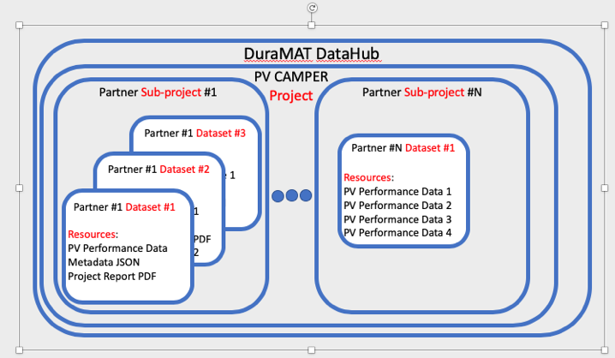

Figure 2. Architecture of the PV CAMPER database within the DuraMAT datahub. Labels in red conform to the baseline DataHub organizational structure.

Each subproject can further be divided into distinct datasets. For example, in sub-project #1 in Figure 2, three CKAN datasets are shown, each containing data and relevant files/metadata to that data. In sub-project #N, data from multiple systems are collected in a single CKAN dataset. The CKAN datasets allow users to consolidate documents and metadata (e.g., Microsoft Word and PDF files) in a single place for sharing. Tabular data is accessible for upload and download via a REST-API. Partners have “Read Only” permissions to all subprojects within the PV CAMPER Project but only the owner of the sub-project has write-permission.

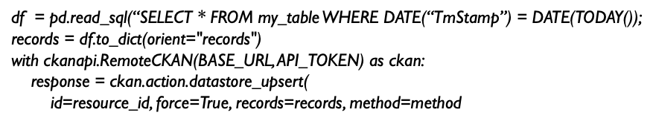

Figure 3. Code for uploading data to the PV CAMPER database.

Figure 3. Code for uploading data to the PV CAMPER database.

Several members have already uploaded data to the site; others were waiting until the MOU was fully executed. In the interim, a committee of researchers from Anhalt and Universidade Federal de Santa Catarina (UFSC) has assumed responsibility for creating a PV CAMPER nomenclature that ensures standardization of data labeling. The development of that nomenclature is informed by DuraMAT Datahub recommendations and by PV CAMPER’s research projects.

**Project Plan for Collaborative Research Study**

PV CAMPER members have four research projects underway, with preliminary results for two of them presented at PVSC and EU-PVSEC in 2019/20. The status of each project is presented below; Participating organizations per project are listed in Table 2, with a summary of each project to follow.

Table 2. Participation of PV CAMPER members in research activities

|  |  |  |  |  |  |
| --- | --- | --- | --- | --- | --- |
| Participating Institution | Albedo | Module Temperature | Over-irradiance | Condensation | Pyranometer\* |
| Anhalt | **Lead** |  |  |  |  |
| CSP |  |  |  |  | **Lead** |
| IRESEN |  |  |  |  |  |
| KIER |  |  |  |  |  |
| KTL |  |  |  |  |  |
| QEERI |  |  |  | **Lead** |  |
| Sandia |  |  |  |  |  |
| SERIS |  |  |  |  |  |
| YU |  |  |  |  |  |
| UFSC |  | **Lead** | **Lead** |  |  |
| LU |  |  |  |  |  |

\*The pyranometer study was put on hold when COVID forced the closure of the CREST calibration lab but is still a project of interest.

**1. Ground-based Albedo Measurements** – led by Sebastian Dittmann of Anhalt

Despite the growth in bifacial PV, there are no standards for ground-based albedo monitoring and only minimal albedo data are available to modelers. Moreover, existing performance models assume albedo remains constant for each substrate type although albedo can change both diurnally and seasonally.

The objectives of this PV CAMPER study are to:

1. Establish a set of best practices for ground-based albedo measurements, which include requirements for ensuring data quality across multiple sites, including type and placement of instrumentation, and calibration and maintenance protocols;
2. Measure albedo diurnal and seasonal shifts across difference climate zones;
3. Quantify the reduction uncertainty in albedo measurements by the above technical approach;
4. Validate simulation methods for rear-side irradiance

The methodology for this study is divided into four parts, as outlined in Table 3.

Table 3. Methodology for albedo study

|  |  |
| --- | --- |
| Part | Method |
| 1 | Quality check of instrumentation |
| 2 | Measurement of rear-side horizontal irradiance (Grear\_hor) |
| 3 | Measurement of rear-side plane-of-array irradiance (Grear\_poa) |
| 4 | Measurement of rear-side plane-of-array irradiance (Grear\_poa) in PV systems (either bifacial or monofacial) |

|  |
| --- |
|  |
| *Figure 4. Preliminary results of one-year albedo data with different measurements setups*: *(left) - Histogram of α for each test site together with mean (µ), median and the standard deviation (σ), (right) - Seasonal variation, monthly average of rear/front side ratio, (Sandia\_VT: no data for October, QERRI: 9-month data only).* |

**References:**   
S. Dittmann, H. Sanchez, L. Burnham, R. Gottschalg, S.Y. Oh, A. Benlarabi, B. Figgis, A. Abdallah, C. Rodriguez, R. Rüther, C. Fell. *Comparative Analysis of Albedo Measurements (plane-of-array and horizontal) at Multiple Sites Worldwide*, 36th EU PVSEC, 2019.

**2. Back-of-Module Temperature Study** – Led by Aline Kirsten de Oliveira of UFSC

Accurate module temperature estimation leads to more accurate energy production forecasts and to a better understanding of the PV degradation process. Yet little is known about the accuracy of different temperature-estimation models in diverse climatic conditions. This study aims to:

1) Measure the temperature behavior of different PV technologies in various climate zones across the globe; and

2) Evaluate the accuracy of temperature-estimation models relative to the measured data from these same sites.

This study encompasses:

* Analysis of temperature-measurement methodologies, information that is key to identifying best practices and building an international standard. Best practices include requirements for ensuring data quality across multiple sites, including type and placement of sensors, and calibration and maintenance protocols;
* The quantified reduction in field-measurement uncertainty, as demonstrated by the above technical approach;
* Assessment of the accuracy of PV module-temperature estimation models;
* Analysis of data to bring greater accuracy to PV performance prediction.

Table 4. Description of the sites and sensors participating in the temperature study.

|  |  |  |  |  |  |  |
| --- | --- | --- | --- | --- | --- | --- |
| **Member Institution** | **Test Site** | **Location** | **Latitude** | **Longitude** | **Global POA Irradiance** | **Back-of-module Temp** |
| **Anhalt** | GER-BBG | Bernburg, Germany | 51.77°N | 11.77°E | SMP10-V | PT1000 |
| **CREST** | UK-LBOR | Loughborough, United Kingdom | 52.76°N | 1.24°W | CMP11 | PT100 |
| **Sandia**  **National Labs** | USA-ABQ | Albuquerque, US | 35.05°N | 106.54°W | SMP11 | Omega Type T |
| IBM | Williston, US | 44.27°N | 73.68°W |
| FSEC | Cocoa, US | 28.41°N | 80.77°W |
| LVRM | Henderson, US | 36.01°N | 114.55°W |
| **SERIS** | SG | Singapore, Singapore | 1.28 °N | 103.87°E | SMP11 | PT1000 |
| **UFSC** | BRA-BTS | Brotas de MacaMaca, Brazil | 12.31°S | 42.34°W | CMP11 | PT1000 |
| **YU** | KOR-GGN | Gyeongsan, South Korea | 35.82°N | 128.76°E | CMP10 | Omega Type T |

|  |
| --- |
| page4image315456 |
| *Figure 5. Preliminary results for one test site, Brotas de Macaúbas-BA, in Brazil depicting the difference in measured and estimated (Ross model) module temperature (a) daily results for September 2018 for mc-Si; (b) hourly results for September 1, 2018 for mc-Si; (c) daily results for September 2018 for CdTe; (d) hourly results for September 1, 2018 for CdTe.* |

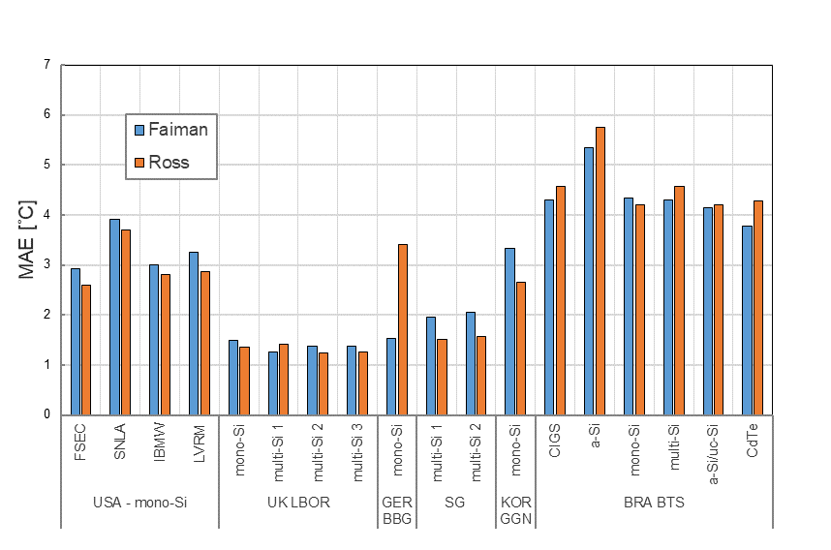

Figure 5. Preliminary results from one year of measurements for all test sites participating in the study of Mean Absolute Error (MAE) between measured and estimated temperatures, using two different models: the Ross and Faiman models.

**References:**

A.K. de Oliveira, M. Braga, L. Burnham, S. Dittmann, R. Gottschalg, T. Betts, C.D. Rodríguez-Gallegos, T. Reindl, S.Y. Oh, R. Rüther. *Comparative Analysis of Module Temperature Measurements and Estimation Methods for Various Climate Zones Across the Globe*, 37th EU PVSEC, 2020.

A.K. de Oliveira, M. Braga, L. Burnham, S. Dittmann, R. Gottschalg, T. Betts, C.D. Rodríguez-Gallegos, T. Reindl, S.Y. Oh, R. Rüther. PV Module Temperature Study: A Comparative Analysis of Measurements and Estimation Methods. 30th International Photovoltaic Science and Engineering Conference (PVSEC-30), Jeju, Republic of Korea: 2020, p. 132.

**3. Over-Irradiance** – led by Marilia Braga of UFSC

Over-irradiance events, which occur when a visible cloud-brightening event (cloud enhancement- or cloud-edge effect) causes a magnification of solar irradiance, can impact the performance of utility-scale PV power plants. Under specific conditions (when the events last longer than 1 min and ambient temperatures exceed 30°C), a sudden burst of over-irradiance can blow string fuses and overload inverters, leading to energy losses.

For this study, each participating PV CAMPER member contributed one year of high-resolution irradiance data collected at a frequency of one second. The UFSC team, led by Marilia Braga, analyzed the data and presented the findings at PVSC-47.

Table 5. Irradiance instrumentation for participating PV CAMPER sites

| **Test Site** | **Sampling / Averaging Intervals** | **Global Tilted Irradiance** | **Global Horizontal Irradiance** | **Diffuse Horizontal Irradiance** |
| --- | --- | --- | --- | --- |
| BRA-FLN | 1s / - | SMP11-V Pyranometer (LT) | SMP22-V Pyranometer | SMP22 Pyranometer on tracker with shading ball |
| BRA-BTS | 1s / - | CMP11 Pyranometer (LT) | SMP11-V Pyranometer | SPN1 Pyranometer |
| GER-BBG | 1s / 10s | SMP10-V Pyranometer (35°) | SMP10-V\* Pyranometer | SMP10-V\* Pyranometer on tracker with shading ball |
| USA-ABQ | 1s / - | CMP11-V Pyranometer  (LT) | CMP22-V Pyranometer | Eppley 848 Pyranometer on tracker with shading ball |
| UK-LBO | 1s / - | CMP11 Pyranometer  (34°) | CMP11-V Pyranometer | CMP11-V Pyranometer on tracker with shading ball |

\* not considered in this paper

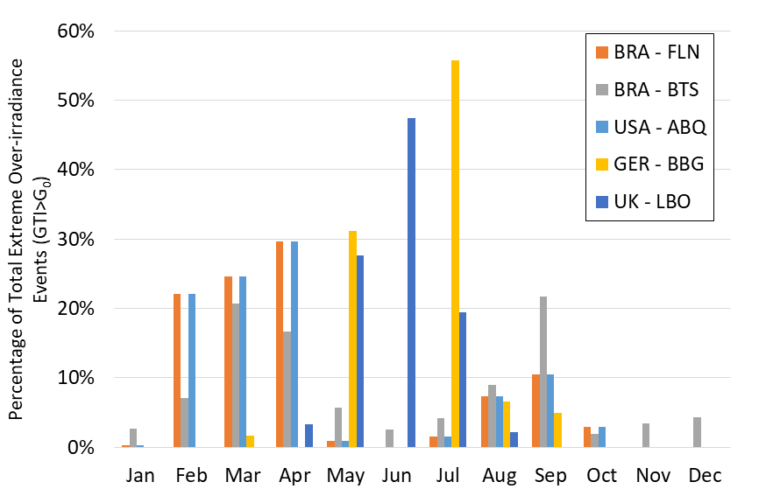

*Figure 6.* *Monthly distribution of tilted extreme over-irradiance events (GTI>G0) detected throughout a full year of data for all five test sites: BRA-FLN (orange bars), BRA-BTS (gray bars), USA-ABQ (light-blue bars), GER-BBG (yellow bars) and UK-LBO (dark-blue bars).*

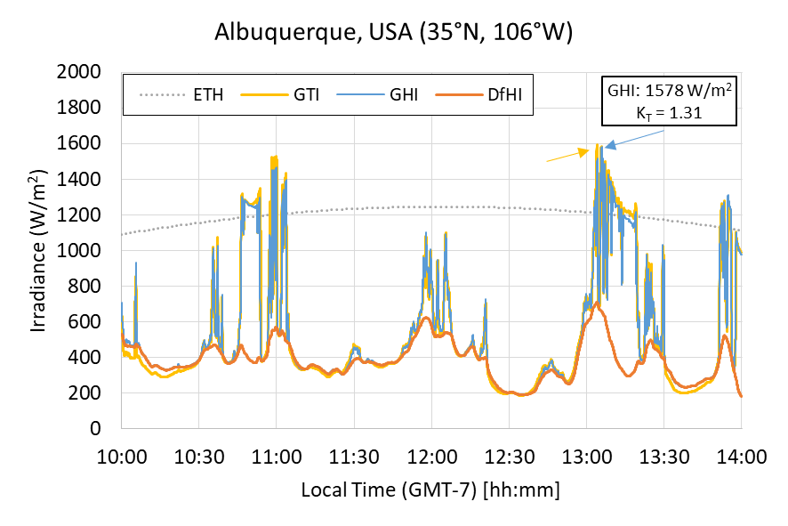

Figure 7. Monthly distribution of tilted extreme over-irradiance events (GTI>G0) detected throughout a full year of data for all five test sites: BRA-FLN (orange bars), BRA-BTS (gray bars), USA-ABQ (light-blue bars), GER-BBG (yellow bars) and UK-LBO (dark-blue bars).

Table 6. Summary of horizontal over-irradiance events for selected sites.

|  |  |  |  |  |
| --- | --- | --- | --- | --- |
|  | **BRA**  **FLN** | **BRA**  **BTS** | **USA**  **ABQ** | **UK**  **LBO** |
| **Number of Over-Irradiance Events** | 2882 | 11251 | 2361 | 3174 |
| **Maximum Peak (W/m2)** | 1703 | 1802 | 1578 | 1426 |
| **Maximum Peak Date** | 20/01/19 | 27/11/19 | 23/04/19 | 15/06/19 |
| **Maximum Peak Event Duration (s)** | 16 | 80 | 64 | 2 |
| **Maximum Peak KT** | 1.22 | 1.31 | 1.31 | 1.24 |
| **Longest Event Duration (s)** | 467 | 1159 | 1291 | 388 |
| **Longest Event Date** | 24/04/19 | 11/04/19 | 17/02/19 | 01/07/19 |

Results obtained so far suggest that 1) over-irradiance events are far more common at low altitudes than previously presumed; 2) a full understanding of over-irradiance as it impacts PV operations requires high frequency GHI and GTI data; and 3) over-irradiance is a serious but unrecognized concern for utility-scale power plants (for both plant design and operation), with a significant number (7.0%) of over-irradiance events lasting one minute or longer and more than half of extreme over-irradiance events occurring in quick succession.

**References:**

M. Braga, A.K. de Oliveira, L. Burnham, S. Dittmann, R. Gottschalg, T. Betts, C. Rodriguez-Gallelos, T. Reindl, R. Rüther. *Over-Irradiance Events: Preliminary Results from a Global Study,* 47th IEEE PVSC, September 2020, 8pp.

M. Braga, A.K. de Oliveira, L. Burnham, S. Dittmann, R. Gottschalg, T. Betts, C. Rodriguez-Gallelos, T. Reindl, R. Rüther. *Occurrence and Impacts of Over-irradiance Events on Utility-scale PV Power Plants.* 30th International Photovoltaic Science and Engineering Conference (PVSEC-30), Jeju, Republic of Korea: 2020, p. 135.

**4. Condensation** – led by Benjamin Figgis of QEERI

Qualitative evidence suggests that moisture plays a major role in PV soiling but quantitative data on the phenomenon are lacking. No studies, prior to this one, have measured condensation on fielded modules as a contributor to soiling.

The objectives of this project are to:

1. Quantify the effect of module condensation on PV soiling (% of soiling variation accounted for by condensation variation);
2. Determine the cause/effect of soiling quantity and composition on condensation occurrence;
3. Evaluate condensation as a predictor of PV soiling rate at different geographic locations; and
4. Improve the understanding, modeling and prediction of PV soiling across different climates/locations.

QEERI has built, calibrated and distributed condensation sensors (*see Figure 8*) to participating members, with the expectation that the sensor and soiling system will be set up and generating data by early August.

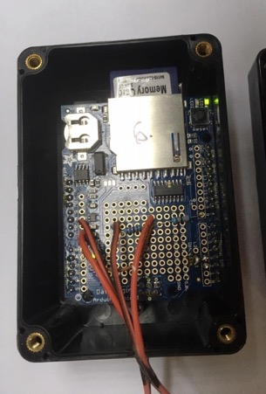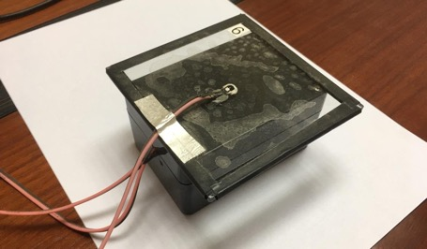

Indicator light

Memory card

Figure 8. Inside of the condensation sensor (left), showing memory card, which should be read every two weeks and glass surface with moisture sensor (right).

Data will be collected for a minimum of one year, with the expectation that the team will collaborate on the development of a soiling model.

**5. Pyranometer Uncertainty** – led by Ralph Gottschalg of Fraunhofer CSP

Pyranometers are especially critical instruments for measuring PV performance and are the baseline for any comparison between sites; it is also well known that pyranometers that have different calibration chains differ in output. To understand those differences requires careful assessment.

The objectives of this project are to:

1) Collect data on pyranometer drift across the PV CAMPER sites under a set of controlled conditions and procedures, including calibration and recalibration by the same laboratory; and

2) develop a tool that can be used by PV Camper participants to calculate point-by-point measurements and time-series-based uncertainties associated with the pyranometer.

This research project, while still of great interest, has stalled for two reasons: 1) the methodology calls for each participant to send one or two pyranometers to CREST (a fully ISO17025 accredited calibration laboratory) at Loughborough University, but Loughborough has been shut down on account of COVID19; and 2) the cost of calibration is significant, and therefore challenging, for most PV CAMPER members.

The decision to create an associate membership category and also a mechanism for external funding may make this study possible but the timing is uncertain.

PART IV. OUTREACH AND COMMUNICATIONS

**PV CAMPER Mission Statement:**

To create a global technical platform that enables pioneering photovoltaic research, validates the performance of emerging technologies in specific climates and helps accelerate the world’s transition to a solar-intensive economy.

**PV CAMPER Website**

The PV CAMPER webpage is located at: <https://energy.sandia.gov/pv-camper>

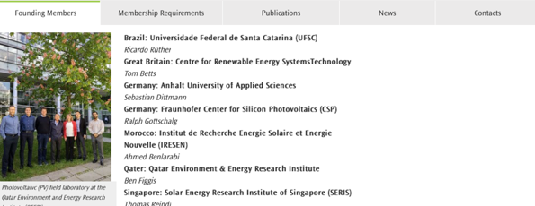

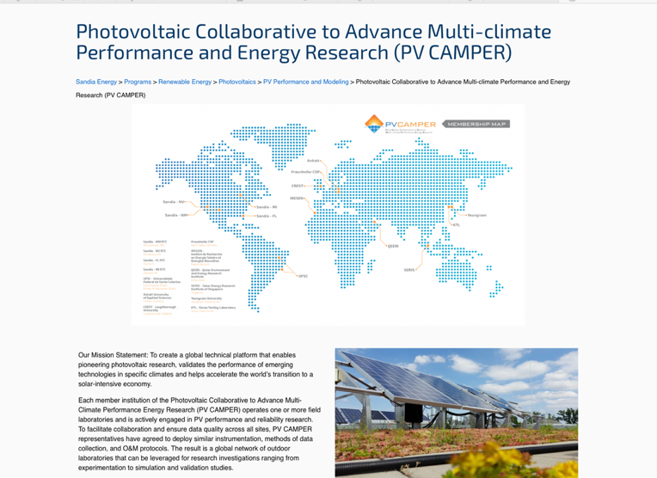

Figure 9. Screenshots of the PV CAMPER website.

**PV CAMPER Logo**

To increase organizational visibility and credibility, PV CAMPER now has its own logo, which was designed by Sandia Creative Services and approved by all members:

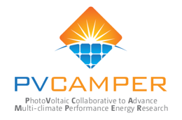

As a related effort, Sandia Creative Services also designed a presentation template that made its debut at IEEE PVSC conference in June:

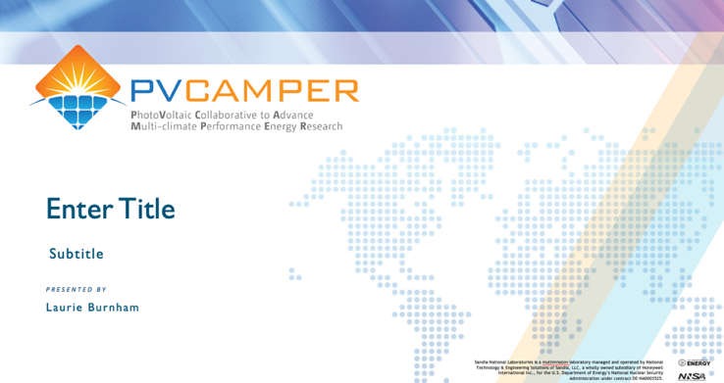

Figure 6 Title page for the PV CAMPER presentation logo

**Trade Publication**

PV CAMPER’s over-irradiance research is described in the September 23, 2020 issue of PV Magazine. Link: <https://www.pv-magazine.com/2020/09/25/over-irradiance-events-affect-utility-scale-pv-components/>

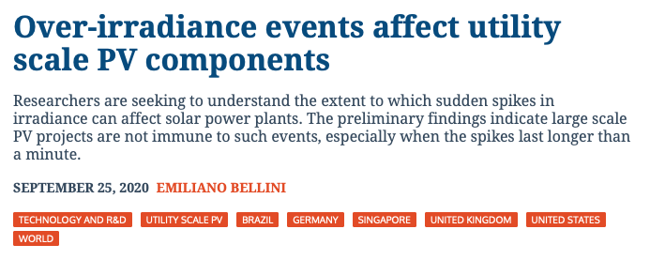

Figure 11. PV CAMPER’s over-irradiance research is described in the September 23, 2020 issue of PV Magazine.

**PV CAMPER Workshop**

A PV CAMPER Workshop, organized by Soo-Young Oh of Yeungnam University, was held on November 10, 2020 at the PVSEC-30 Conference in Jeju Korea.

Table 7. Agenda for the PV CAMPER Workshop at PVSEC-30.

|  |  |  |  |
| --- | --- | --- | --- |
| **PT Time** | **Presentation Title** | **Speaker** | **Affiliation** |
| 14:00-14:20 | Overview and status of PV CAMPER | Laurie Burnham | Sandia |
| 14:20-14:35 | Influence of pyranometer uncertainty on yield measurements | Ralph Gottschalg | CSP |
| 14: 35-14:50 | Temperature Study: comparative analysis of measurements and estimation methods | Aline Kirsten | UFSC |
| 14:5 0-15:05 | Measurement method of Albedo | Sebastian Dittmann | Anhalt |
| 15: 05-15:20 | Soiling (condensation) | Benjamin Figgis | QEERI |
| 15:30-15:45 | Occurrence and impacts of over-irradiance events on utility-scale PV power plants | Marilia Braga | UFSC |
| 15:45-16:00 | Outdoor operating temperature modeling of PV modules, including transient effect | Soo-Young Oh | YU |
| 16:00-16:30 | Panel Discussion | Sebastian Dittmann | Anhalt |

**Conference Participation**

The following papers were accepted for presentations in 2019/20:

* M. Braga, A.K. de Oliveira, L. Burnham, S. Dittmann, R. Gottschalg, T. Betts, C.D. Rodríguez-Gallegos, T. Reindl, R. Rüther. *Over-Irradiance Events: Preliminary Results from a Global Study,* 47th IEEE PVSC, September 2020, 8pp.
* A.K. de Oliveira, M. Braga, L. Burnham, S. Dittmann, R. Gottschalg, T. Betts, C.D. Rodríguez-Gallegos, T. Reindl, S.Y. Oh, R. Rüther. *Comparative Analysis of Module Temperature Measurements and Estimation Methods for Various Climate Zones Across the Globe*, 37th EU PVSEC, 2020.
* M. Braga, A.K. de Oliveira, R. Rüther, L. Burnham, S. Dittmann, S.Y. Oh, A. Benlarabi, J.H. Choi, M. Ebert, B. Figgis, R. Gottschalg, K.S. Kim, T. Reindl. *PV CAMPER: Colaboração Internacional para Avanços na Pesquisa Multiclimática em Energia Solar Fotovoltaica*, XIII CBENS, 2020.
* L. Burnham, *Photovoltaic degradation in desert environments: a tale of two sites*, PV Days Brazil, 13 March 2020. (Note: this event was cancelled on 12 March in response to a local COVID outbreak.)
* S. Dittmann, H. Sanchez, L. Burnham, R. Gottschalg, S.Y. Oh, A. Benlarabi, B. Figgis, A. Abdallah, C. Rodriguez, R. Rüther, C. Fell. Comparative Analysis of Albedo Measurements (plane-of-array and horizontal) at Multiple Sites Worldwide, 36th EU PVSEC, 2019.

PART V. ORGANIZATIONAL GOVERNANCE

PV CAMPER is governed by an Executive Committee, which was formed in 2020. when elections were held for the positions of chair, vice chair, and directors of research and external affairs. Members of the Committee (see Table 8) were elected on Dec.9, 2020 for one-year terms, which are renewable for another year, as determined by a majority of members. PV CAMPER’s organizational structure is further defined in the appendix to this document.

Table 6. PV CAMPER Executive Committee for 2021

|  |  |  |
| --- | --- | --- |
| **Position** | **Elected Official** | **Member Institution** |
| Chair | Ralph Gottschalg | Fraunhofer CSP |
| Vice Chair | Laurie Burnham | Sandia National Labs |
| Director of Research | Sebastian Dittmann | Anhalt University |
| Director of External Relations | Aline Kirsten Vidal de Oliveira | Universidade Federal de Santa Catarina |

**Member Representatives**

The participants in this project provide in-kind support in the form of personnel hours, travel costs and equipment/facilities needed for collaborative research projects. We meet at a minimum once a year but may engage in person at conferences and other research-related events, such as workshops.

* Laurie Burnham, Sandia PI for the project and organizational lead in 2020.
* Daniel Riley, PV analyst at Sandia who has advised on the PV CAMPER technical platform.
* Sebastian Dittmann, Research Fellow at Anhalt University in Germany, co-lead of PV CAMPER and lead for the albedometer study.
* Ralph Gottschalg, Director of Fraunhofer CSP and lead for the pyranometer study. Also participating from Fraunhofer are Matthias Ebert and David Dassler.
* Soo-Young Oh, professor *emeritus* at Yeungnam University in South Korea.
* Ben Figgis, research program manager at QEERI in Qatar and lead for the soiling project.
* Ahmed Benlarbi head of PV module development at IRESEN in Morocco.
* Thomas Reindl, deputy CEO of SERIS in Singapore
* Carlos Rodríguez-Gallegos, SERIS
* Ricardo Ruther, professor of electrical engineering at UFSC in Brazil.
* Marilia Braga and Aline Kirsten Vidal de Oliveira, graduate students in electrical engineering also actively participate in the project and are leading both the temperature and over-irradiance research projects.
* Tom Betts, professor at Loughborough University’s Centre for Renewable Energy Systems Technology.
* Christopher Fell, physicist and photovoltaics expert at the CSIRO Energy Center in Australia who participates as an *ad hoc* member.
* Jun-Hong Choi, engineer at Korea Testing Laboratory.

APPENDIX

**PV CAMPER ORGANIZATIONAL STRUCTURE**

OVERVIEW

PV CAMPER is an organization of internationally recognized research institutions dedicated to cross-climate photovoltaic (PV) research. This global network, with researchers and field laboratories distributed across multiple climate zones, investigates emerging solar challenges, supports the development accurate performance models and validates novel technologies in specific climates. Ultimately, PV CAMPER aims to accelerate solar deployment worldwide, thus helping transition the global economy to a more solar-intensive future.

OBJECTIVES

The purpose of this document is to describe PV CAMPER’s organizational structure, including its governing body, terms-of-office for elected officers and election guidelines. This organizational structure has been reviewed and approved by the majority of PV CAMPER’s institutional members.

MEMBERSHIP

1. Membership in PVCAMPER falls into two categories:  
   -- Full membership
   * Full members are research institutions that meet technical and institutional criteria specified in the PV CAMPER Memorandum of Understanding.
   * Full members shall appoint one or more representatives to participate in organizational activities and fulfill the obligations of membership.

* Associate membership (two categories)
  + Research memberships: organizations that do not meet the criteria needed for primary membership but may contribute data and/or expertise to a specific PV CAMPER research project.
  + Supporting memberships: industry partners that provide direct funding or in-kind support in exchange for access to data, PV CAMPER expertise, research support or cross-climate product evaluation.
  + Associate memberships will be formally documented with a statement outlining the terms and conditions of the person’s/organization’s participation in PV CAMPER. Such a document will be signed by the PV CAMPER Chair and a representative of the Associate Member.

1. Resignation and termination

Any member may resign by filing a written resignation with the Chair. Institutional membership may also be terminated by a majority vote of the membership if 1) a representative from that institution fails to attend 50 percent of meetings in a year without explanation and/or if 2) that institution fails to participate in at least one PV CAMPER research project per year.

MEETINGS OF MEMBERS

**Regular Meetings**

The PV CAMPER Chair will host a one-hour online meeting for all PV CAMPER primary representatives on the second Wednesday of every month. That meeting will be posted in advance and a reminder notice, with an agenda, sent to all representatives. The Chair will determine the agenda with input from the members.

**Annual Meetings**

PV CAMPER will have one in-person meeting per year hosted by a member institution and at a place and time deemed convenient for the majority of members, preferably in association with a major conference or other international gathering. Associate members may be invited to join the annual meeting, at the discretion of the Executive Committee.

**Special Meetings**

Special meetings may be called by the chair or may be requested by any member pending approval by the Chair.

**Voting**

Full members will have one representative cast a single vote in PV CAMPER elections.

All issues to be voted on will be decided by a simple majority of those present at the meeting at which the voting occurs, or by those participating via an online process, but votes caste must represent a quorum of at least 50 percent of PV CAMPER members.

OFFICERS  
PV CAMPER will be governed by an Executive Committee that consists of a Chair, Vice-Chair, and two committee members, each of whom shall represent a separate institution. All members of the Executive Committee will serve a one-year term, renewable for another year, as determined by a majority of members.

Candidates for the above positions may be nominated by any member, including the candidate, but no person may run for more than one position on the Executive Committee. A person may be nominated for multiple positions, but shall have to choose among them in advance of the election.

Also, in the event of a tie, a run-off election will be held.

**Executive Committee**

* **Chair**  
  The Chair will have the following duties:
* Preside at all meetings of the full organization and Executive Committee
* Oversee the activities of the Executive Committee, including elections
* Provide organizational vision to ensure the continued health and growth of PV CAMPER
* Serve as editor-in-chief of the PV CAMPER Annual Report
* **Vice-Chair**

The Vice-Chair will have the following responsibilities:

* Perform all the duties of the President during their absence
* Provide support, as needed, to members of the Executive Committee
* Distribute meeting minutes to all members
* **Committee Members-at-Large**

Two Members-at-Large will serve on the Executive Committee and will execute the following duties:

* Provide general support to the Chair and Vice Chair
* One member shall be designated “Research Director” of PV CAMPER, responsible for overseeing (tracking) PV CAMPER’s multiple research activities and for bringing vision to PV CAMPER’s research portfolio, encouraging/identifying/recruiting new projects, as appropriate.
* One member shall be designated “Outreach and Communications Director,” responsible for identifying/recruiting new members that meet the primary membership criteria outlined in the PV CAMPER Memorandum-of-Understanding and the associate membership criteria listed above. This individual shall also be responsible for increasing the visibility of the organization through multiple publicity channels, including social media and the press.
* Members-at-Large will have the option of forming subcommittees
* The number of Members-at-Large may expand in number, as needed, and as determined by a majority vote of PV CAMPER primary members. Should such an expansion take place, this document will be updated accordingly.

Any member of the executive committee who fails to fulfill any of his or her requirements may be asked by the Chair to forfeit his or her seat. The Chair will then oversee an election to fill the vacancy.

Members of the Executive Committee will not receive any compensation for their services on behalf of PV CAMPER.

**Election of Officers**

Nominations for members of the Executive Committee will be solicited from all primary members. The election will be held at the PV CAMPER annual meeting, unless circumstances require elections outside of the annual meeting. Those officers elected/re-elected will serve a term of one (1) year, commencing at the next meeting following the annual meeting.