# Proceedings of the ASME 2021 15th International Conference on Energy Sustainability

**ES2021**

**June 16-18, 2021, Virtual, Online**

**ES2021-64050**

Development and Testing of a 20 kW Moving Packed-Bed Particle-to-sCO2 Heat Exchanger and Test Facility

|  |
| --- |
| Kevin J. Albrecht1, Hendrik F. Laubscher1, Matthew D. Carlson1, Clifford K. Ho1  1Sandia National Laboratory, Albuquerque, NM |

Abstract

*This paper describes the development of a facility for evaluating the performance of small-scale particle-to-sCO2 heat exchangers, which includes an isobaric sCO2 flow loop and an electrically heated particle flow loop. The particle flow loop is capable of delivering up to 60 kW of heat at a temperature of 600 °C and flow rate of 0.4 kg/s. The loop was developed to facilitate long duration off-sun testing of small prototype heat exchangers to produce model validation data at steady-state operating conditions. Lessons learned on instrumentation, control, and system integration from prior testing of larger heat exchangers with solar thermal input were used to guide the design of the test facility. In addition, the development and testing of a novel 20-kWt moving packed-bed particle-to-sCO2 heat exchanger using the integrated flow loops is reported. The prototype heat exchanger implements many novel features for increasing thermal performance and reducing pressure drop which include integral porting of the sCO2 flow, unique bond/braze manufacturing, narrow plate spacing, and pure counter-flow arrangement. The experimental data collected for the prototype heat exchanger was compared to model predictions to verify the sizing, thermal performance, and pressure drop which will be extended to multi-megawatt heat exchanger designs in the future.*

Keywords: Heat Exchanger, Particle, CO2

Nomenclature

T temperature

P pressure

ṁ mass flow rate

h enthalpy

cp specific heat

1. INTRODUCTION

Concentrating solar power (CSP) with thermal energy storage has the potential to increase the penetration of intermittent renewable generators on the electric grid by providing dispatchable renewable energy. However, current systems are limited by high capital cost and low thermal-to-electric conversion efficiency. A promising path to low-cost and dispatchable renewable energy is increasing the operating temperature of CSP plants through the use of alternative heat transfer fluids and coupling to a high-efficiency supercritical carbon dioxide (sCO2) power cycle [1, 2]. In order to meet the capital cost requirements for particle CSP, a particle-to-sCO2 heat exchanger is required which effectively transfers thermal energy at low cost. Thus, experimental data for high performance particle-to-sCO2 heat exchangers implementing cost effective manufacturing techniques is required to derisk the technology [3].

The present effort focuses on producing such data by developing small-scale test loops for rapid evaluation of prototype heat exchanger designs [4]. The test loops consist of an isobaric sCO2 flow loop and electrically heated particle flow loop. The operating conditions of the small-scale test loops have been established to keep equipment costs as low as possible while still allowing for informative experiments to be conducted. The following sections detail the heat exchanger test facility and a prototype unit based on the design being considered for the G3P3 system [5].

1. **DEVELOPMENT OF A HEAT EXCHANGER TEST BED**

In order to evaluate the steady-state performance of a prototype heat exchanger, a system that is capable of recirculating both particle and sCO2 flows while holding inlet temperatures and flow rates constant for extended periods of time is required. Commonly, particle heat transfer measurements are made using batch mode test which are notoriously unreliable due to the inherent transient nature of the experiment. In addition, it is common for experiments to be conducted without a representative working fluid [6, 7] or no fluid at all. The development of the test facility described in this section seeks to alleviate these issues through constructing a heat exchanger test facility where the particle and sCO2 flows can be circulated indefinitely and achieve true steady-state operating conditions by maintaining accurate control over the heat exchanger inlet temperatures.

The piping and instrumentation diagram of the heat exchanger test facility is provided in Figure 1. As previously discussed, the system consists of two integrated loops for the particle and sCO2 heat transfer media. The sCO2 flow loop is based on the configuration presented by Carlson et al. [8] and used in prior testing of prototype heat exchangers [9] with only minor changes based on lessons learned. The sCO2 flow loop is isobaric and implements a dense phase pump on the cold side of the system for fluid circulation. The cold and hot side of the system are separated through a recuperator which heats the sCO2 flow leaving the pump and cools the sCO2 leaving the heat exchanger. A bypass line around the recuperator and heat trace on the sCO2 heat exchanger inlet and outlet connections allow for full control over the temperature of the sCO2 at the heat exchanger inlet. Heat rejection from the sCO2 is accomplished using water-cooled heat exchanger on both the main sCO2 flow after passing through the recuperator and pump recirculation lines. However, the pump recirculation line temperature is maintained using a chiller since temperatures below ambient are occasionally required to maintain sCO2 density at an acceptable value (>850 kg/m3). Control of the sCO2 flow is accomplished through a combination of a variable frequency drive on the pump and throttle valve. The sCO2 flow loop layout meets the requirements of indefinite operation with complete control over sCO2 inlet temperature and flow rate.

Although the layout of the sCO2 flow loop is consistent with prior efforts, the method of construction differs due to trying to keep the cost of construction and testing prototype heat exchangers as low as possible. Maximum operating temperature and maximum allowable working pressure were selected to be 500 °C and 20 MPa based on the limitations of commonly available parts. At the selected operating conditions, the allowable stress for stainless steel can meet the design requirements which helps to expedited manufacturing and reduce costs.

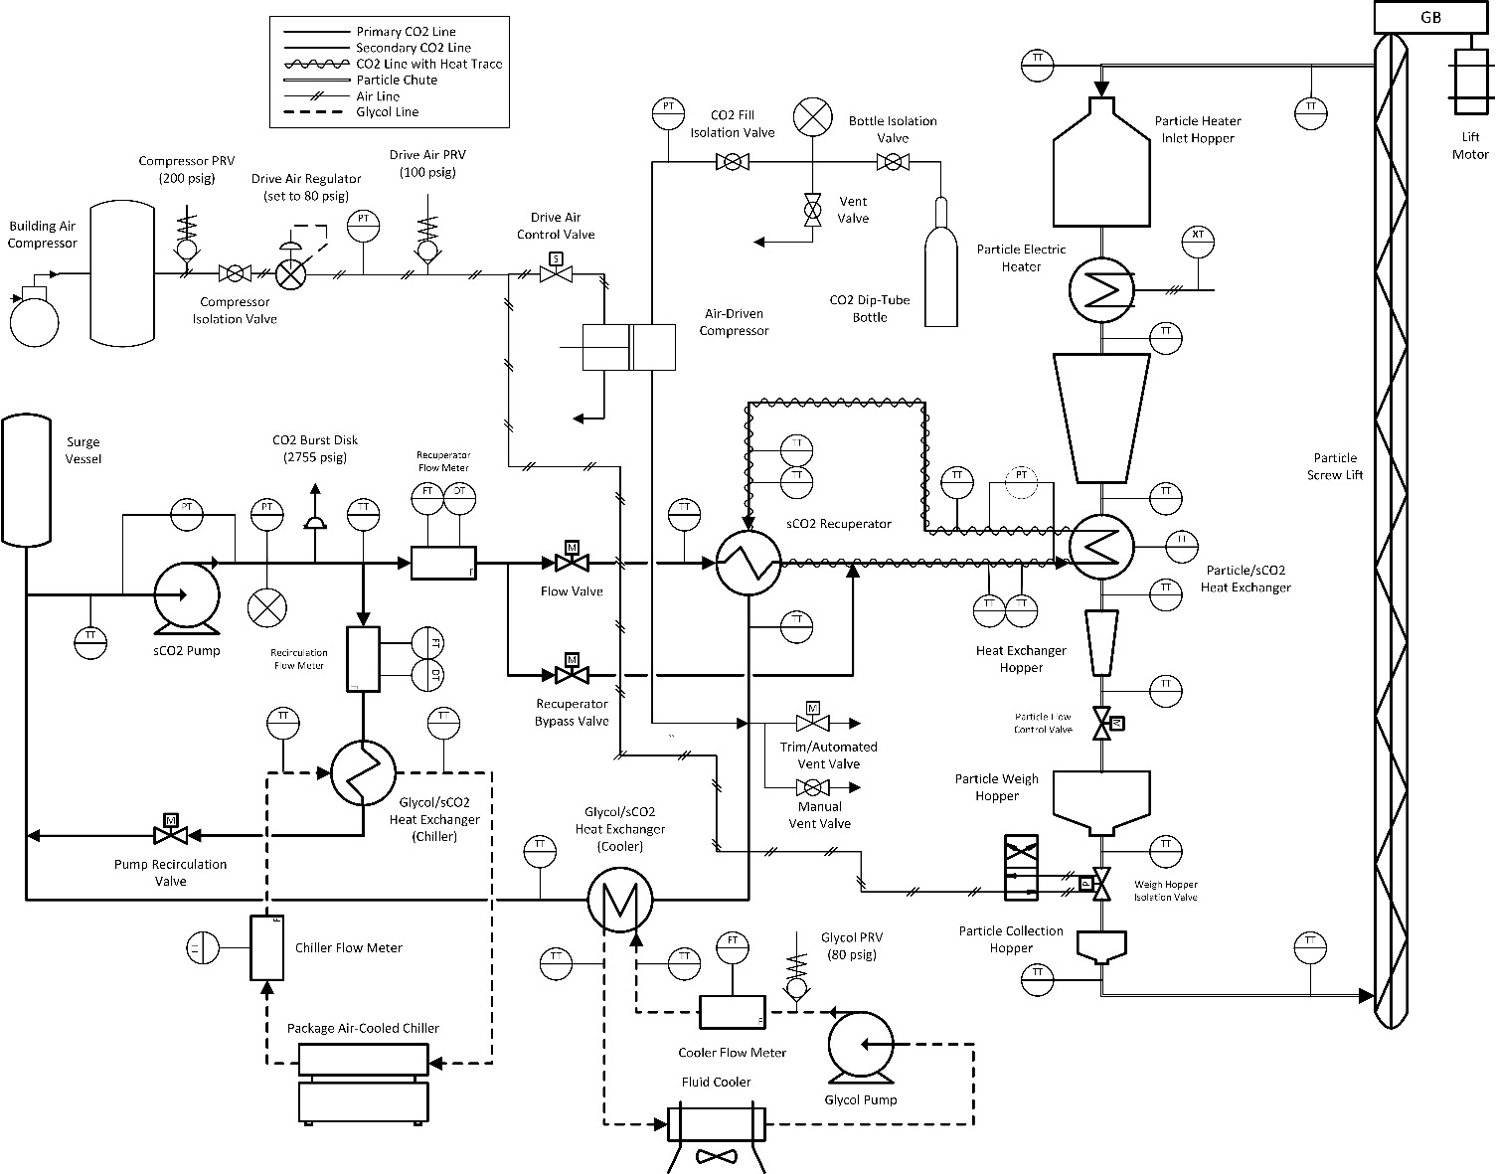

**Figure 1:** Piping and instrumentation diagram (P&ID) of the integrated particle and sCO2 flow loops for testing a 20-kWt prototype particle-to-sCO2 heat exchanger

An illustration of the geometric arrangement of the particle/sCO2 heat exchanger test facility is provided in Figure 2. The particle flow loop uses a vertically integrated design with gravity driven flow, which allows for the particle flow rate through the entire system to be governed using one control valve at the outlet of the heat exchanger. Circulation of the particle flow through the system is provided using a custom high-temperature screw auger constructed from stainless steel using standard pipe sections and off-the-shelf components. The electrical heater is designed using commonly available cartridge heaters and custom formed hoppers to create a staggered tube array for heating the particle flow. Mass flow measurements are made gravimetrically using an inline weigh hopper that is continuously charged and discharged during operation. The system layout was designed based on many lessons-learned from system integration and instrumentation in the prior 100 kW SuNLaMP testing. Many of the same design features (inline weigh hopper, thermal equilibration length, redundant instrumentation) have also been included in the 1 MWt G3P3 heat exchanger subsystem.

One key issue that is typically encountered in performance characterization of particle-based components is accurate measurements of average particle temperature. In heat exchanger performance evaluation, measuring the inlet and outlet temperature accurately is necessary for calculating temperature driving force as well as verifying closure of the energy balance to establish confidence in the measurements. The system configuration shown in Figure 2 implements thermal equilibration lengths both above and below the heat exchanger and reduced cross-sections in the areas where thermocouples are installed. Since particle thermal conductivity is relatively low compared to fluid systems, installing a single temperature probe can result in a point temperature measurement that is not necessarily representative of the bulk flow. In addition, low heat transfer coefficients between the temperature probe and particle bed can amplify the stem effect leading to large measurement error. Thus, temperature measurements must be made with as small of probe diameter as possible to minimize measurement uncertainty.

Furthermore, high-temperature particle mass flow rate measurement has notoriously been an issue with particle-based CSP. Gravimetric measurements of particle flow rate are currently the best approach to reliable measurement, but this approach requires the forethought to have an inline weigh hopper installed in they system and consideration for allowing the hopper to expand without affecting the load cell measurement.

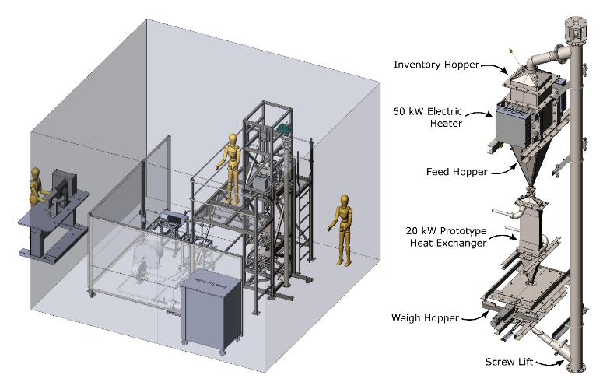

**Figure 2:** Illustration of the integrated particle and sCO2 flow loops and detailed layout of the particle flow loop with integrated 20 kWt subscale heat exchanger

1. **HEAT EXCHANGER SUBSCALE PROTOTYPE**

A subscale manufacturing demonstration and performance characterization of a small-scale prototype heat exchanger was developed based on the geometry being pursued for the G3P3 project. The subscale heat exchanger was developed at the 20 kWt scale using stainless steel. The stainless-steel construction was identified as a method of expediting delivery and keeping prototype cost low while still being able to test the novel design features. The reduced heat exchanger duty was implemented by lowering the plate dimensions to 0.5 m by 0.2 m and the number of plates in parallel to seven. However, the design features to be tested will be representative of larger scale heat exchangers. The novel features include:

* Integral porting on the sCO2 side to eliminate plate nozzles, reduce pressure drop, lower costs, improve sCO2 flow distribution, and allow for counter-flow arrangement
* Combined bonded and brazed “caseless” heat exchanger manufacturing to allow for closer plate spacing (3 mm), an unobstructed particle flow path, and minimal assembly and welding
* Higher thermal performance through closer plate spacing, higher approach temperature, and counter flow arrangement

The final geometry of the 20-kWt subscale heat exchanger is displayed in Figure 3 with an exploded view to depict the sCO2 and particle flow paths. In addition, the 20 kWt prototype design point operating conditions are provided in Table 1. The heat exchanger manufacturing and sCO2 channel layout was performed by Vacuum Process Engineering. Figure 4 and Figure 5 display the completed heat exchanger. The performance measurement of heat transfer coefficient and pressure drop are reported in a future section.

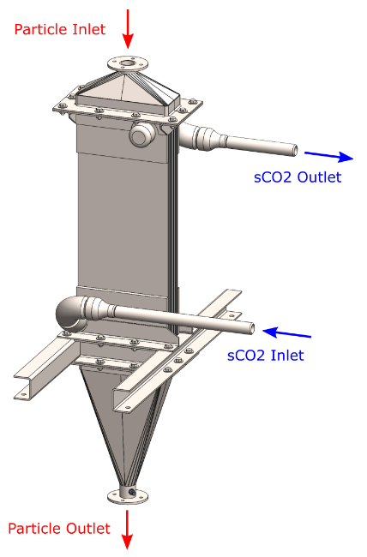

**Figure 3:** Illustration of 20 kWt prototype heat exchanger design and exploded view capturing conceptual sCO2 and particle flow paths

**Table 1:** Design conditions for the 20 kWt prototype heat exchanger



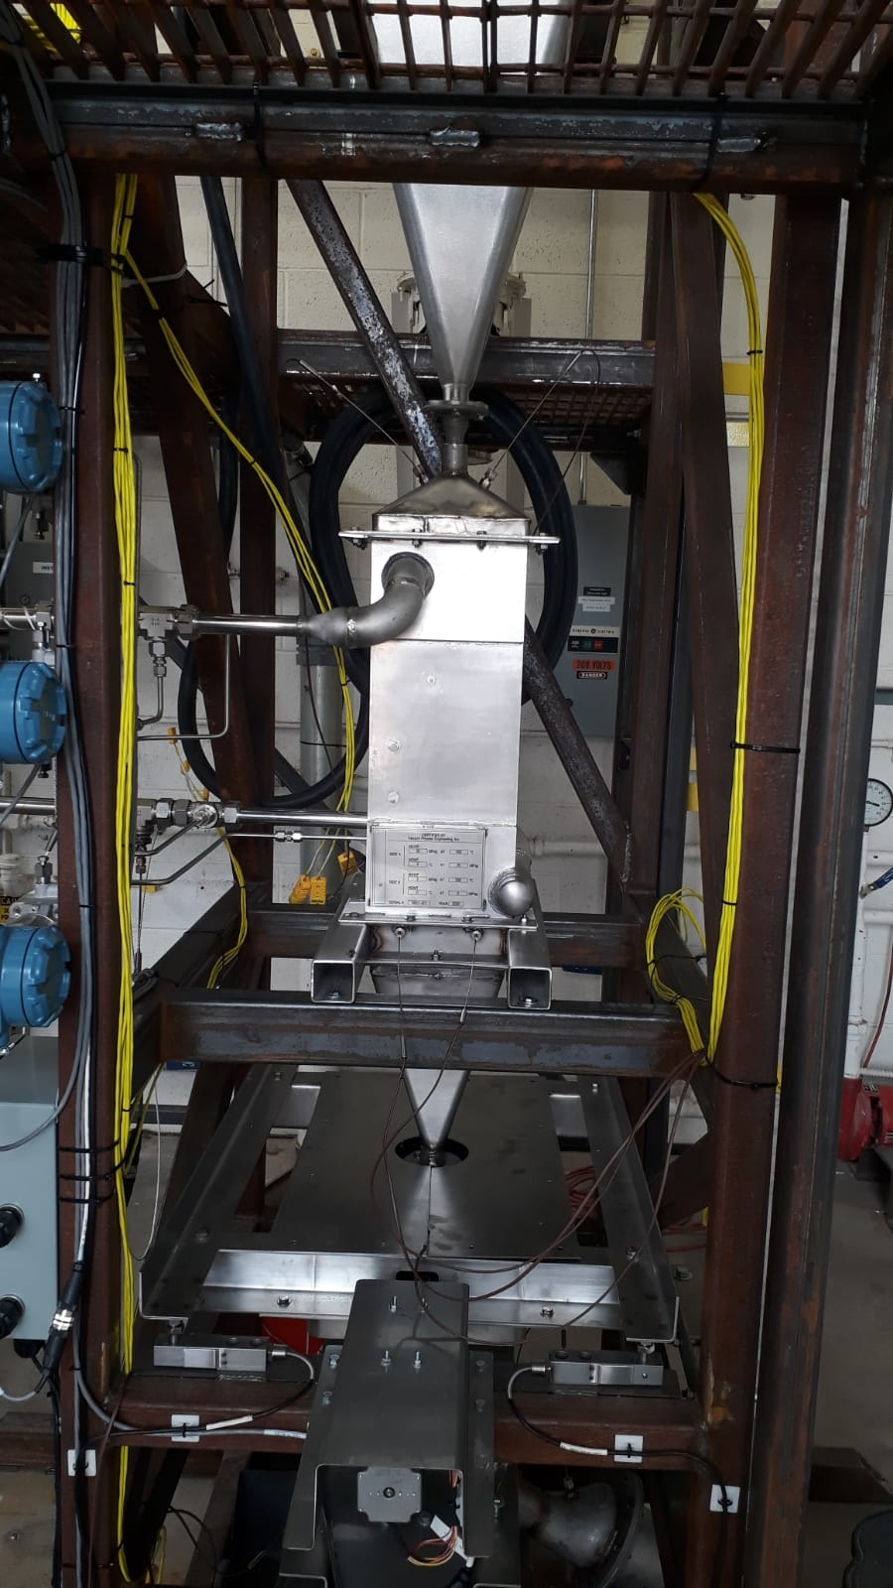

**Figure 4:** Photo of the manufactured 20 kWt prototype heat exchanger installation

1. **RESULTS AND DISCUSSION**

The performance testing of the 20-kWt subscale prototype was conducted using the previously discussed integrated particle and sCO2 flow loops. In order to understand how the performance of the prototype heat exchanger was affected by operating conditions performance measurements for the overall heat transfer coefficient and pressure drop were made every 50 °C beginning at a particle inlet temperature of 200 °C until the design point condition was reached.

The approach to conducting the thermal performance tests was to begin with the system at ambient temperature and flow sCO2 and particles at the design flow rates. The particle heat exchanger inlet temperature was slowly ramped to the desired operating temperature by controlling the electrical heat addition in the heater. Once the electric heater reached the target inlet temperature, PID control of the electric heater was enabled and the flow valves on the sCO2 side were adjusted to manipulate the sCO2 inlet temperature to the desired value. The temperature measurements were allowed to stabilize and remain at steady state for approximately one hour prior to moving to a new operating condition. Steady-state operating conditions for performance evaluation were identified as periods of greater than 15 min with less than ±1 °C of variation at all four heat exchanger boundaries.

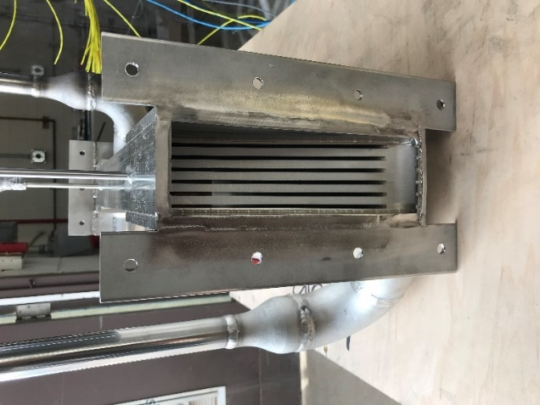

**Figure 5:** Photo of 20 kWt prototype particle-to-sCO2 heat exchanger core using integral porting and a combination of bonding and brazing to create the “caseless” shell-and-plate geometry

The steady-state measurements of thermal performance for the 20-kWt subscale prototype are displayed in Figure 6. The overall heat transfer coefficient is observed to be approximately 300 W/m2-K at the intermediate temperature operating conditions (400-600 °C) and displays a slight dependence on particle inlet temperature in the range of 200-400 °C. The measured values of performance were verified through evaluating closure of the heat exchanger energy balance and agreement between upstream and downstream temperature measurements in the system. The measured performance for the G3P3 20 kWt subscale prototype is a large improvement over the performance of the first particle/sCO2 heat exchanger prototype developed in a prior project that had overall heat transfer coefficient values of 50-70 W/m2-K [9] and difficulty in measuring the performance due to system integration issues. The observed overall heat transfer coefficient for the 20 kWt prototype is between a factor of 4-6 times better than any other known particle to sCO2 heat exchanger.

Pressure drop (Figure 7) was measured from inlet to outlet of the heat exchanger and observed to be less than 7 kPa (0.04%) at the design point conditions which is in line with CFD modeling results and builds confidence in future large scale heat exchangers meeting pressure drop requirements. The measured pressure drop of the 20 kWt prototype was expected to be substantially lower than the 1-2% target for a primary power cycle heat exchanger due to a combination of the intermediate temperature sCO2 properties (lower viscosity and higher density), larger channel dimensions because the allowable stress of stainless steel (105 MPa) at 550 °C is more than triple the value of IN617 (30 MPa) at 800 °C, and the small plate dimensions resulting in shorter flow path lengths. Overall, the measured performance and operation of the 20-kWt subscale prototype provides confidence in moving packed-bed heat exchanger technology progressing toward meeting the needs of a particle-based CSP system.

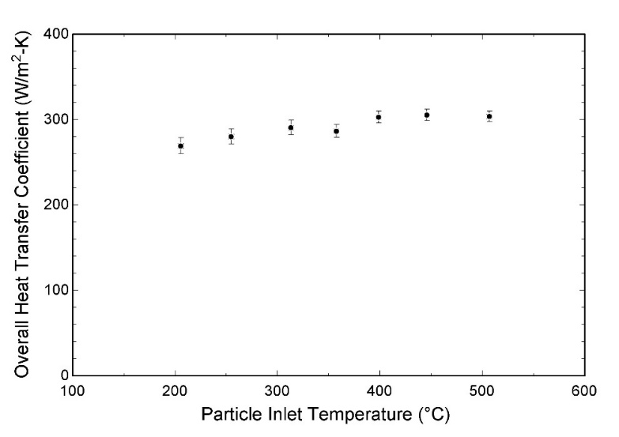

**Figure 6:** Steady-state measurements of overall heat transfer coefficient of the 20-kWt subscale prototype particle/sCO2 heat exchanger at various particle inlet temperature

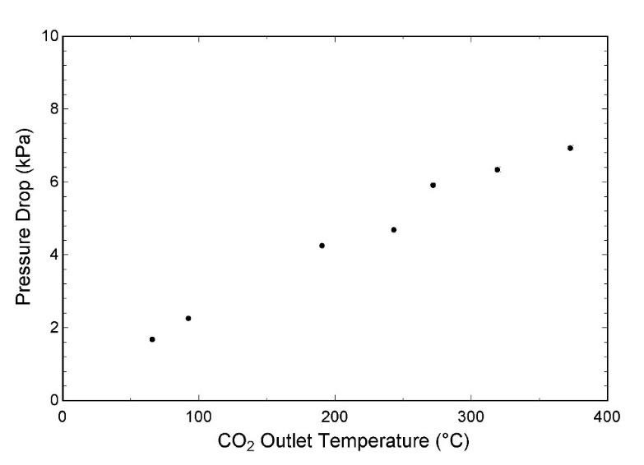

**Figure 7:** Steady-state measurements of pressure drop over the entire 20-kWt subscale prototype particle/sCO2 heat exchanger at sCO2 design flow rate (~0.1 kg/s)

1. **CONCLUSION**

A small-scale heat exchanger test facility was developed with the purpose of rapidly evaluating prototype heat exchanger performance at temperatures up to 600 °C. The test facility was used to evaluate a novel 20 kWt prototype that demonstrated overall heat transfer coefficients up to 300 W/m2-K and pressure drop well below the targets of commercial system. The test facility will serve as a future platform for iterating on heat exchanger designs and producing important data for technology development.

**ACKNOWLEDGEMENTS**

The authors would like to acknowledge the contributions of Vacuum Processing Engineering and Solex Thermal Science on the 20-kWt heat exchanger design and manufacturing.

This work was funded in part or whole by the U.S. Department of Energy Solar Energy Technologies Office under Award Number 34211 and 34152. This report was prepared as an account of work sponsored by an agency of the United States Government. Neither the United States Government nor any agency thereof, nor any of their employees, makes any warranty, express or implied, or assumes any legal liability or responsibility for the accuracy, completeness, or usefulness of any information, apparatus, product, or process disclosed, or represents that its use would not infringe privately owned rights. References herein to any specific commercial product, process, or service by trade name, trademark, manufacturer, or otherwise does not necessarily constitute or imply its endorsement, recommendation, or favoring by the United States Government or any agency thereof. The views and opinions of the authors expressed herein do not necessarily state or reflect those of the United States Government or any agency thereof.

Sandia National Laboratories is a multimission laboratory managed and operated by National Technology & Engineering Solutions of Sandia, LLC, a wholly owned subsidiary of Honeywell International Inc., for the U.S. Department of Energy’s National Nuclear Security Administration under contract DE-NA0003525.  
  
**REFERENCES**

|  |  |
| --- | --- |
| [1] | M. Mehos, C. Turchi, J. Vidal, M. Wagner, Z. Ma, C. Ho, W. Kolb, C. Andraka and A. Kruizenga, "Concentrating Solar Power Gen3 Demonstration Roadmap," National Renewable Energy Laboratory, Golden, 2017. |
| [2] | K. J. Albrecht, M. L. Bauer and C. K. Ho, "Parametric Analysis of Particle CSP System Performance and Cost to Intrinsic particle Properties and Operating Conditions," in *ASME 2019 13th International Conference on Energy Sustainability*, Bellevue, 2019. |
| [3] | C. K. Ho, M. Carlson, K. J. Albrecht, Z. Ma, S. Jeter and C. M. Nguyen, "Evaluation of Alternative Designs fo a High Temperature Particle-to-sCO2 Heat Exchanger," in *ASME 12th International Conference on Energy and Sustanability*, Lake Buena Vista, 2018. |
| [4] | H. F. Laubscher and K. J. Albrecht, "Particle-to-sCO2 Heat Exchanger Experimental Test Station Design and Construction," in *SolarPACES 2020*, Albquerque, 2020. |
| [5] | C. K. Ho, K. J. Albrecht, L. Yue, B. Mills, J. Sment, J. Christian and M. Carlson, "Overview and Deisgn Basis for the Gen 3 Particle Pilot Plant (G3P3)," in *SolarPACES 2019*, Daegu, 2019. |
| [6] | H. Al-Ansary, A. El-Leathy, Z. Al-Suhaibani, S. Jeter, D. Sadowski, A. Alrished and M. Golob, "Experimental Study of a Sand-Air Heat Exchanger for Use With a High-Temperature Solar Gas Turbine," *Journal of Solar Energy Engineering,* vol. 134, pp. 041017-1-7, 2012. |
| [7] | T. Baumann and S. Zunft, "Development and performance assessment of a moving bed heat exchanger for solar central receiver power plants," in *SolarPACES 2014*, Beijing, 2015. |
| [8] | M. D. Carlson and C. K. Ho, "A Particle/sCO2 Heat Exchanger Testbed and Reference Cycle Cost," in *Proceedings of the ASME 10th International Conference on Energy Sustainability*, Charlotte, 2016. |
| [9] | K. J. Albrecht, M. D. Carlson, H. F. Laubscher, R. Crandell, N. DeLovato and C. K. Ho, "Testing and Model Validation of a Prototype Moving Packed-Bed Particle-to-sCO2 Heat Exchanger," in *SolarPACES 2019*, Daegu, South Korea, 2019. |
| [10] | Z. Ma, G. Glatzmaier and M. Mehos, "Fluidized Bed Technology for Concentrating Solar Power With Thermal Energy Storage," *Journal of Solar Energy Engineering,* vol. 136, no. 3, p. 031014, 2014. |
| [11] | K. J. Albrecht and C. K. Ho, "Design and operating considerations for a shell-and-plate, moving packed-bed, particle-to-sCO2 heat exchanger," *Solar Energy,* vol. 178, pp. 331-340, 2019. |