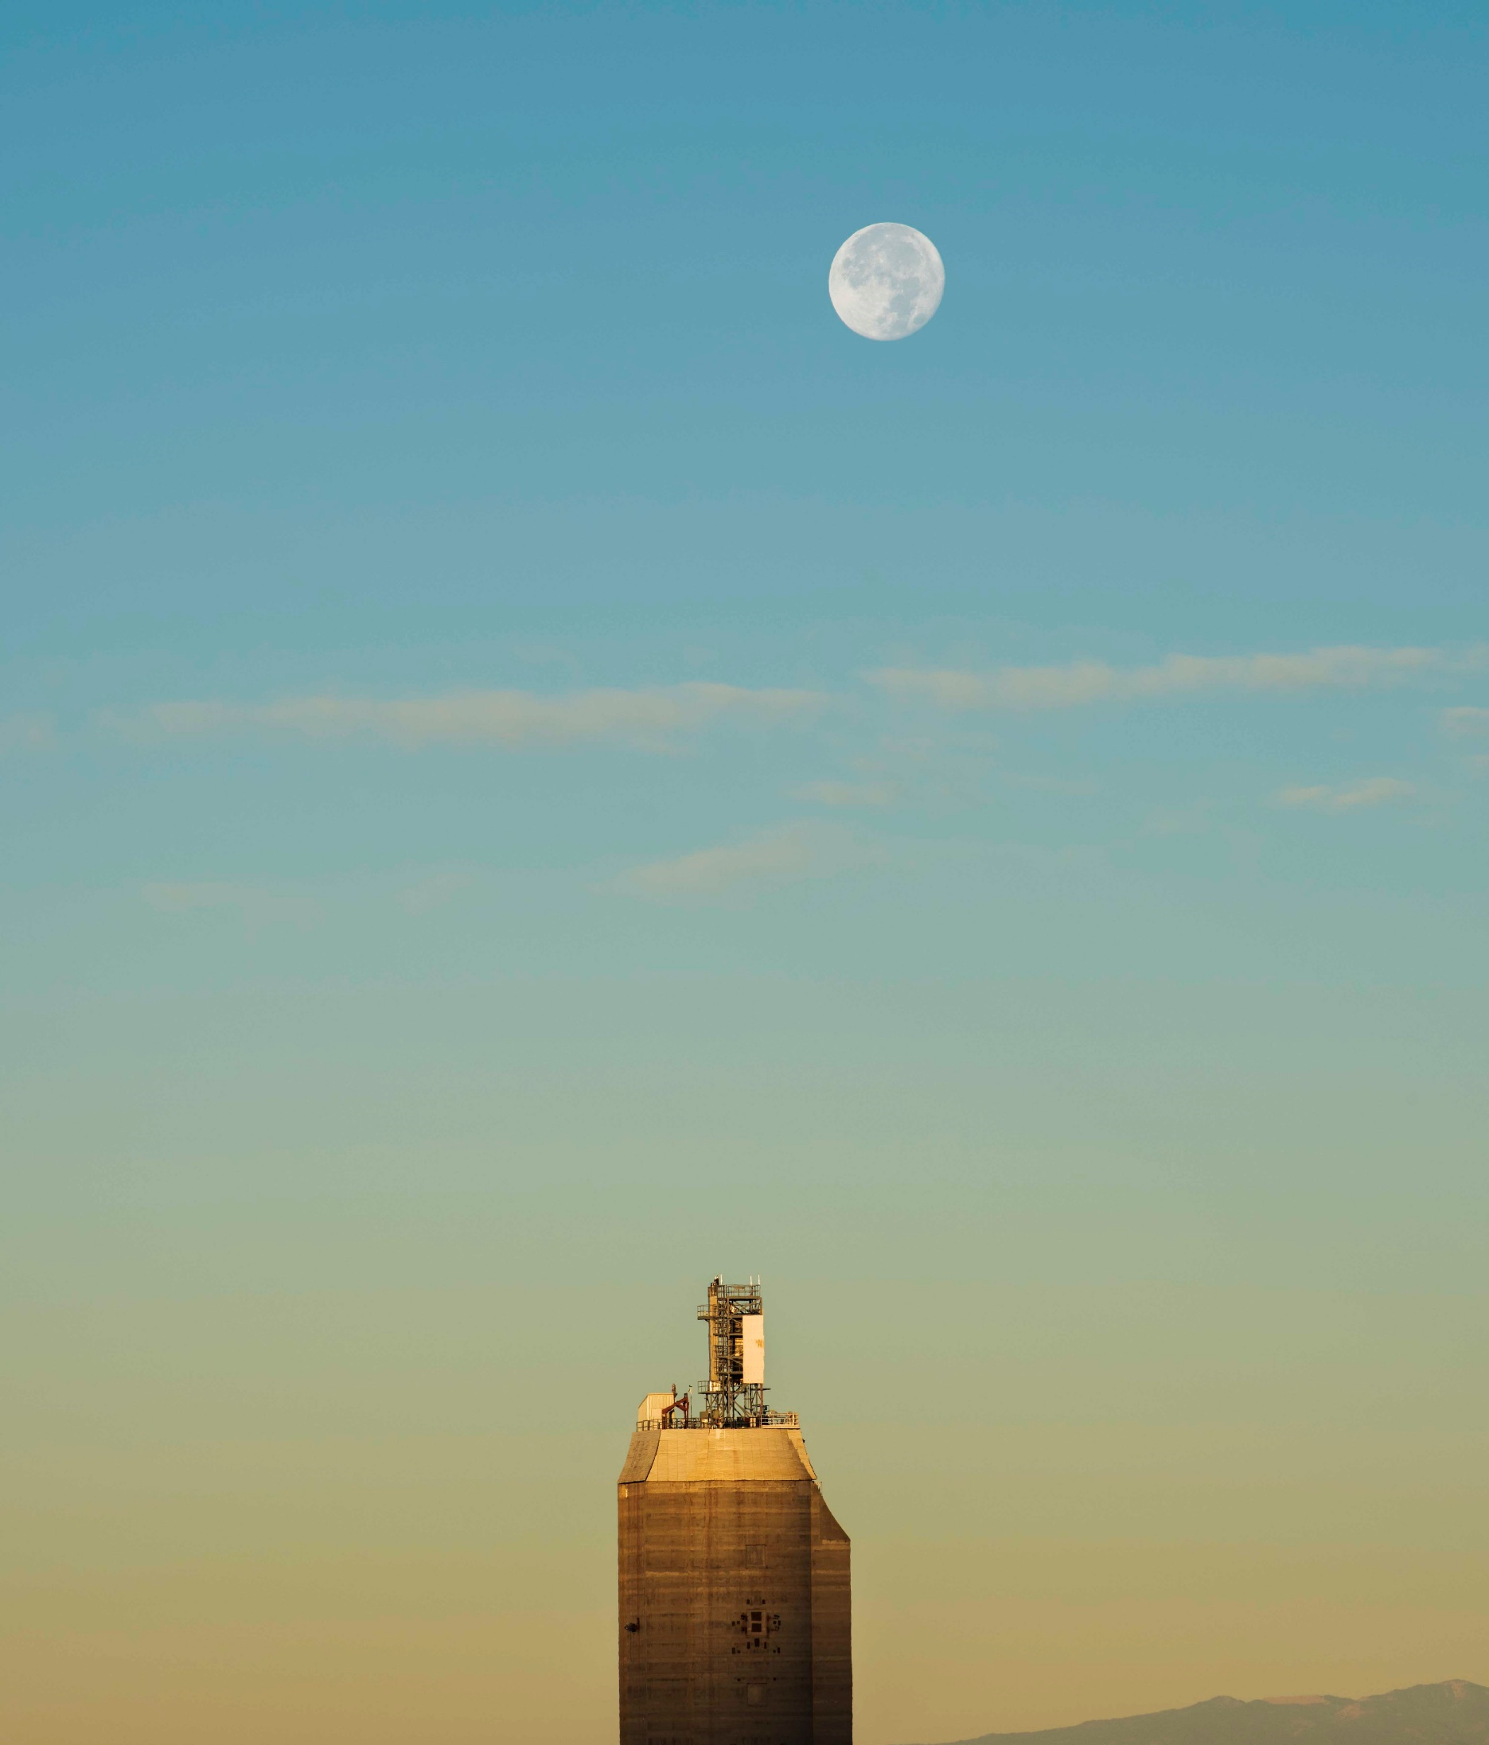
Sandia National Laboratories Heat Exchanger Test Facility

Integrated Solar & Thermal Energy Science Department, 08823

Table of Contents
System Overview 1
System Parameter Table 2
sCO₂ Loop Specifications 4
Particle Loop Specifications 7
Instrumentation and Data Collection 9
Heat Exchanger Installation 9
Start-Up, Operation, and Shut Down Procedures 11
Operating Costs 12
Appendix A – Sensor Locations and Ranges 13
Appendix B – Drawings and Diagrams 17

System Overview
The heat exhanger test stand at Sandia National Laboratories is a facility for prototype 20 – 40 kW_{th} particle to sCO₂ heat exchanger performance analysis, available for use by external partners such as private industry and technology developers, universities, equipment manufacturers, government agencies, and national laboratories. The test stand consists of multiple different particle, CO₂, air, and glycol flow loops for precise control of system pressures, densities, flow rates, and temperatures (see Table 1).
The test stand allows for flexible installation of prototype heat exchangers within a 22x30x40” (length/depth/height) test area, centrally located within a vertically-integrated, continous circulation, high temperature particle loop. An accompanying sCO₂ heat extraction system is adjacent, placed on a rolling skid for adaptable installation. Dry-cooling and chiller coupled glycol flow loops provide heat extraction from the sCO₂ loop with combined 60 kW_{th} sCO₂/glycol heat exchangers The entire system is controlled remotely from a separate control room for operator safety. The system must be operated by a trained Sandia staff member. A detailed P&ID diagram of the system is provided in Appendix B – Drawings and Diagrams.
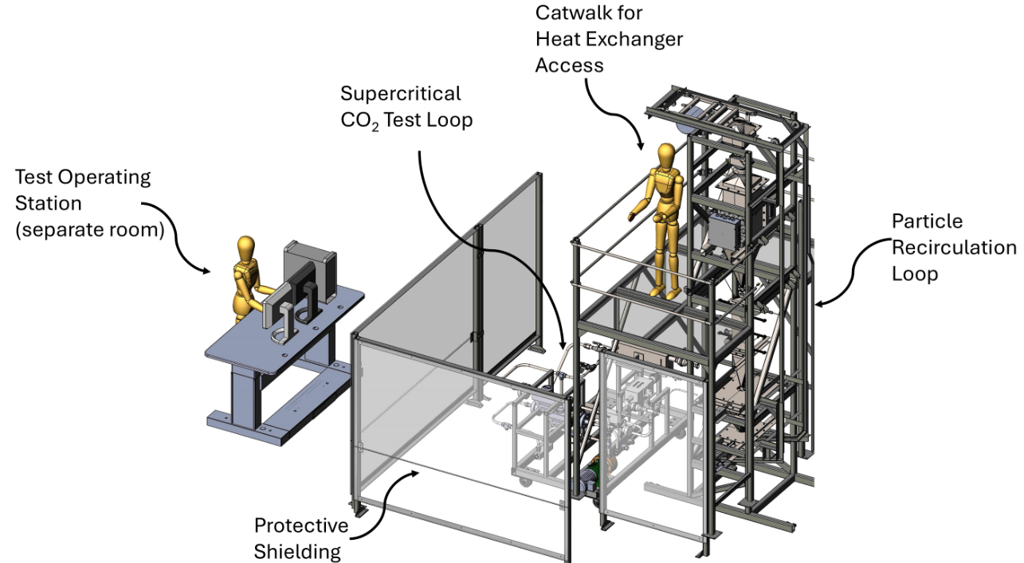
Figure 1: Heat Exchanger Test Stand CAD Visualization. Actual test facility is split into two separate rooms: a control room for all remote operations and data acquisition, and the adjacent 350 ft² test cell containing the flow loops. Additional features of the test cell not depicted include tools, outlets, 480V/200A power, fire suppression systems, liquid CO₂ supply, and a 3-ton overhead crane.
Actual test conditions vary by heat exchanger design and accompanying equipment (inlet/outlet hardware, flow control mechanisms, pressure ratings). However, Sandia’s Heat Exchanger Test Stand can accommodate the following conditions:
Table 1: Overview of Operating Conditions for Primary Fluid Loops at the Heat Exchanger Test Stand
 | sCO2  Loop | Particle  Loop | Air  Supply | Glycol  (Loop 1) | Glycol  (Loop 2)
Flow Rate | 0-250 g/s | 0-250 g/s | 0-1000 slpm | 0-10 gpm | 0-10 gpm
Supply Temperature Range | 30-575 °C | 25-775 °C | 0-400 °C | 20-50 °C | 15 - 50 °C
Pressure Range | 1160 – 2500 psig (8-17.2 MPa) | N/A | 0 – 130 psig  (0-0.9 MPa) | 0 - 30 psig  (0-0.2 MPa) | 0 - 30 psig  (0-0.2 MPa)

System Parameter Table
The table below summarizes the parameters, design attributes, and operating conditions for heat exchangers that can be supported by the heat exchanger test stand. These include temperature and flow rate ranges, compatible working media, pressure, available system interfaces, and heat exchanger construction materials. Together, these parameters define the operating envelope and integration capabilities of the test stand for evaluation of heat exchanger performance. All parameters supported are contingent on safe operation of the heat exchanger at the desired conditions. Actual test conditions must be confirmed with Sandia National Laboratories personnel for feasibility. For example, minimum operating pressure for the sCO₂ side is listed as 8 MPa (lowest pressure for supercritical conditions) but it is not feasible to maintain 8 MPa and heat to 575 °C while maintaining required sCO₂ density.
Table 2: Operating parameters and design attributes of heat exchangers supported for integration to the sCO2 and particle loops.
Parameter | Supercritical CO₂ Side | Particle Side
Heat Exchanger Inlet Temperature Range | 30-575 °C | 25-775 °C
Heat Exchanger Outlet Temperature Range | 30-700 °C | 25-600 °C
Operating Pressure | 1160 – 2500 psig  (8-17.2 MPa) | Atmospheric
Flow Rate | 0-250 g/s | 0-250 g/s
Density Range | 850 -960 kg/m³ | N/A, dependent on particle type.
Heating | 20 kW electric heating, or recovery of carried sCO₂ heat via recuperation. | 60 kW electric heating.
Cooling | Water/glycol air cooler, water/glycol chiller, cold sCO₂ mixing. | Air, sCO₂ heat extraction.
Flow Passage Sizes and Allowable Heat Exchanger Envelope | Inlet/outlet piping: ¾–1 ½ in. diameter; inlet-to-outlet centerline spacing: 8–48 in. Can support any height difference between inlet and outlet piping within the 40 in. tall test area. | Variety of inlet cross sectional areas supported with in 24x30 in. space, for heat exchangers up to 40 in. tall including inlet and outlet hoppers.
Heat Exchanger Connection/Integration | Grayloc, Swagelok, NPT threaded, welded, and ANSI flange connections supported. | Flanged or welded inlet and outlet hopper (heat exchanger specific) with flexible steel support bars.
Supported Fluids/Heat Transfer Media | Liquid CO₂ from siphon tube bottles or dewar. | Sintered bauxite, engineered oxides, additional materials possible upon request.
Supported Heat Exchanger Design Material | Inconel, stainless steel, ceramic, or other materials contingent on pressure testing verification of design rating at temperature. | Variety of design materials including metals (Inconel, stainless steel, titanium, etc.), ceramics (silicon carbide, alumina, etc.) contingent on adequate strength and temperature capabilities.
Insulation | 1-2 in. thick Alkaline Earth Silicate blanket layers. | 1-2 in. thick Alkaline Earth Silicate blanket layers.
Instrumentation | RTD direct sCO₂ temperature, K-Type thermocouple external surface temperature, digital pressure transducers, digital differential pressure transducers, Coriolis Flow Meters for density and mass flow. | K-type thermocouples for direct particle temperature, K-type thermocouples for external surface temperatures, mass flow via catch bin mass measurement.

sCO₂ Loop Specifications
The sCO₂ loop is constructed of 1” stainless steel 316 tubing and designed for 17 MPa and 575 ⁰C operating conditions. The loop is mounted on a rolling skid frame for ease of integration with various heat exchanger designs. Major components of the loop include a circulating pump, two Coriolis meters, variable-position valves, an electric heater, a recuperator, electrically actuated vent valves, instrumentation, and water/glycol heat exchangers for both a dry cooling unit and a chiller. All components are controlled remotely from a centralized, standalone computer in the control room.
Inline flow control valves are used in combination with the 1.5 HP sCO₂ pump to vary the flow rate between 0-250 g/s. The sCO₂ pump is limited to a minimum density of 830 kg/m³, an operating condition that must be maintained at all times for testing.

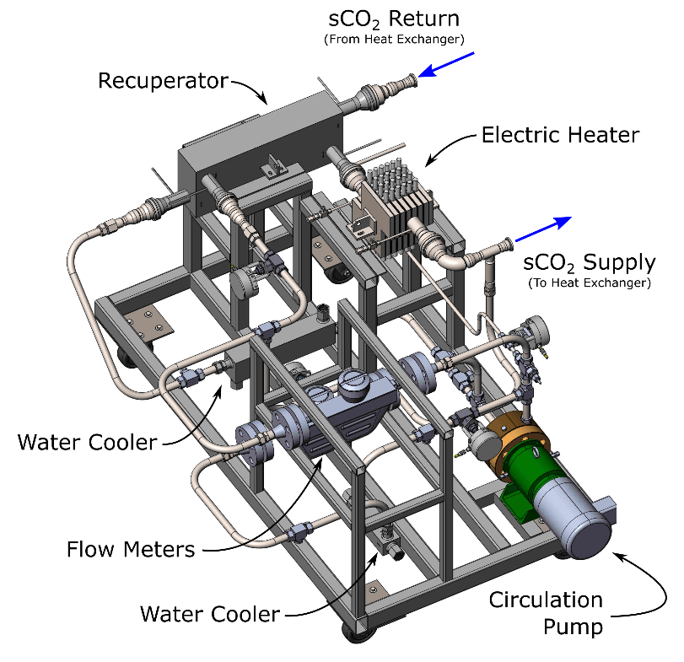
Figure 2: Sandia 575 °C sCO₂ Loop CAD Visualization
The recuperator is the primary method of preheating sCO₂ to test conditions prior to the heat exchanger inlet. The recuperator recovers heat from high temperature sCO₂ outlet by the heat exchanger to heat low temperature sCO₂ from the pump.
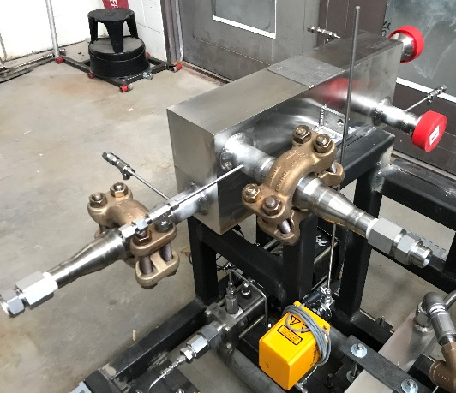
Figure 3: Sandia sCO2 Recuperator. Designed for 235 kW heat load, capable of raising 20°C cold sCO₂ to 575 °C when recovering heat outlet by the heat exchanger at 620 °C. Maximum operating pressure of 20.0 MPa.
A 20-kW electric heater is used for start-up and to provide auxiliary heat to the sCO₂, if required. The heater consists of 36 individual cartridge heaters, oriented to disrupt an upward flow of sCO₂ for maximum heater contact duration and surface area.
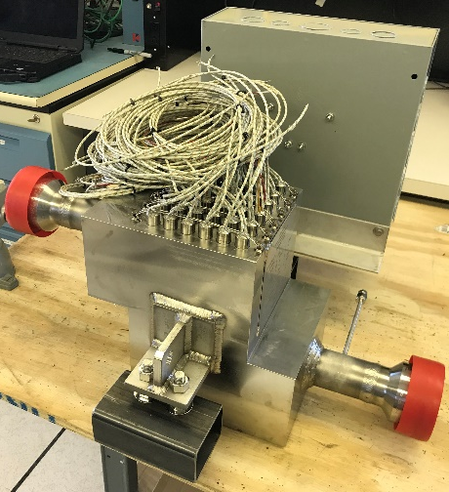
Figure 4: Sandia sCO₂ Heater. Designed for 20 kW heat load, uses 480V, three phase cartridge heaters to achieve a maximum outlet temperature of 580 °C. Maximum operating pressure of 20.0 MPa.
Multiple flow paths exist in the loop for controlling sCO₂ temperatures and properties. A cold loop holds most of the system inventory and circulates sCO₂ between the pump and a water/glycol heat exchanger coupled to a dry cooling unit, capable of reducing sCO₂ temperatures from 575 ℃ to ambient. An additional heat exchanger, coupled to a glycol chiller, can be employed for additional cooling capacity and to reach temperatures 5 ⁰C below ambient.
A hot loop circulates high temperature sCO₂ through the sCO₂ heater, the recuperator, and the heat exchanger. Isolation or mixing of the hot and cold sCO₂ loops is controlled with variable-position needle valves, though the two flow paths cannot be completely isolated while maintaining pumped flow. However, flow control valves sending sCO₂ through the recuperator or bypassing the recuperator can be varied, controlling the amount of preheat received by the sCO₂ at the heat exchanger inlet.
Temperature set point and ramping within the sCO₂ loop is achieved by manipulating these flow configurations and the sCO₂ heater power. Precise inlet sCO₂ temperatures 30-575 °C ± 5°C can be achieved and held steady for 8 hours of continuous testing (overnight or unmanned testing is not currently supported).
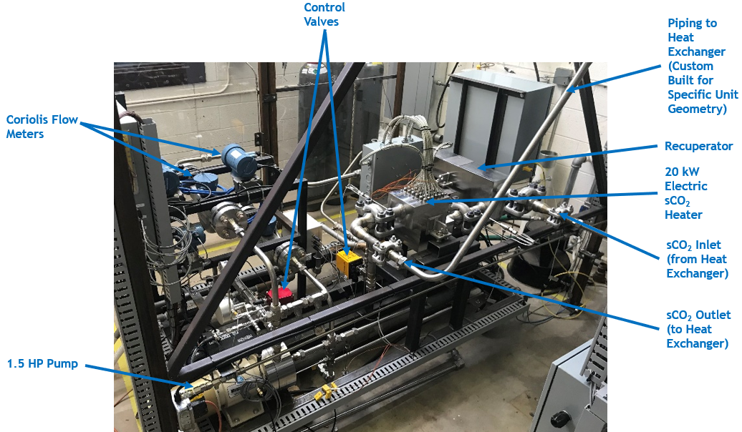
Figure 5: Sandia sCO₂ Loop. Actual loop in current state is insulated with 1-2” layers of Alkaline Earth Silicate blankets. Inlet and outlet locations on the loop are fixed, but piping between the loop and heat exchanger can be custom fabricated to accommodate specific heat exchanger geometries.
The loop may operate from supercritical conditions at 1100 psig (8 MPa) up to 2500 psig (17.2 MPa). A pressure relief system is installed in the cold loop at the outlet of the pump. This consists of a burst disk, a high-flow vent valve, and a low-flow vent valve. The low-flow and high-flow vent valves can be set for any desired pressure, ultimately determining the operating pressure of the system. Both valves can be manually triggered and can be set to remain open for either a duration of time or until a desired pressure is reached. Maximum set points for the valves are 2500 psig (17.2 MPa) on the low-flow vent and 2600 (17.9 MPa) on the high-flow vent. The burst disk is set for 2755 psig (19.0 MPa) but, with a 5% range, may open as low as 2620 psig (18.0 MPa).

Particle Loop Specifications
The particle loop is designed for circulation of granular media. Carbo HSP 40/70 particles are the standard used in this loop, though many particle types and sizes are supported. The loop is electrically heated with a 60-kW heater to provide heat exchanger inlet temperatures up to 775 °C at flow rates up to 250 g/s.
Particle flow rate is controlled with a slide gate style valve on a linear actuator. Though flow rates 0-300 grams/second are supported, steady state flow over long duration tests is most reliable between 50-250 g/s. Actual flow rates achievable may be limited by the specific heat exchanger design and geometry.
Recirculation of particles is accomplished using a skip hoist and collection bin which refills the vertically oriented heater, after which all flow is gravity driven. A skip hoist was selected for recirculation due to the higher operating temperature capabilities and particle size/material flexibility, compared to screw augers.
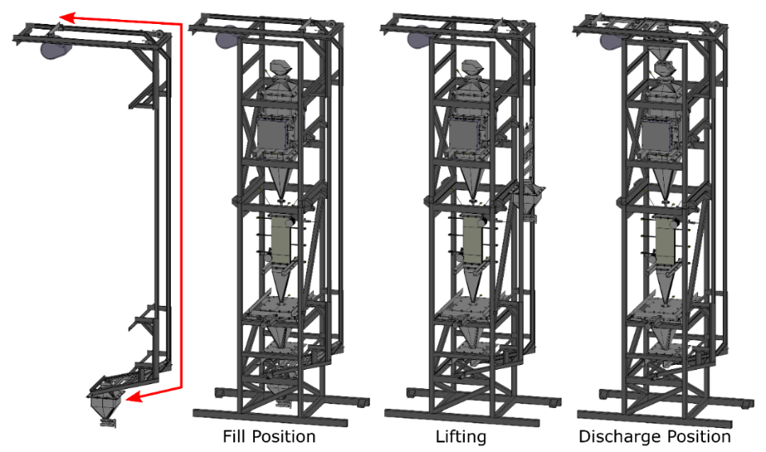
Figure 6: Particle skip hoist fill, lifting, and discharging positions. The skip hoist can be manually or automatically triggered to carry particles from the bottom of the particle loop to the heater at the top. Dwell time for discharging can be custom programmed by the user to accommodate different skip inventories and flow changes from particle sizes.
The particle heater bank consists of 42 electric cartridge heaters, with an internal particle volume of 0.06 m^3 (about 260 lbs of particles). At maximum flow rate, the particles will pass through the heater bank in 10 minutes. At 50 g/s, particles spend over 40 minutes in the heater. Therefore, heater power must be varied drastically from 0-60 kW to maintain temperature control with changing flow rates. Heater power and outlet temperature are monitored/varied from the control room.
The particle flow path from top to bottom consists of the particle heater, a heat exchanger inlet hopper (typically designed for packed beds though fluidized beds can be supported), the heat exchanger, a heat exchanger outlet hopper, the variable-position slide gate, and a weigh hopper collection bin. The weigh hopper is mounted on scales to enable real-time measurement of hopper inventory, with time-dependent mass change used to determine particle mass flow rate. The weigh hopper collection bin empties into the skip hoist at automated, customizable intervals. The skip hoist can operate continuously, but requires approximately 90 seconds to raise, empty, and lower. This is the limiting factor for the particle flow rate.
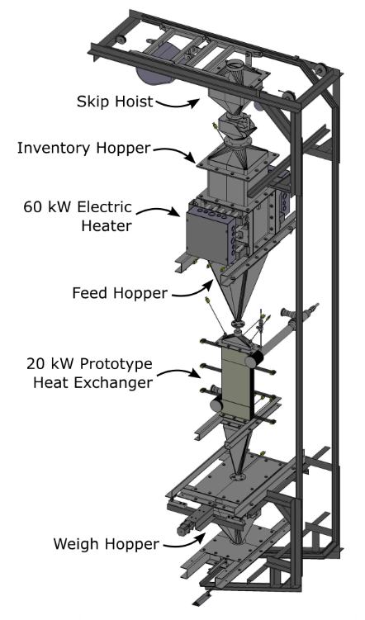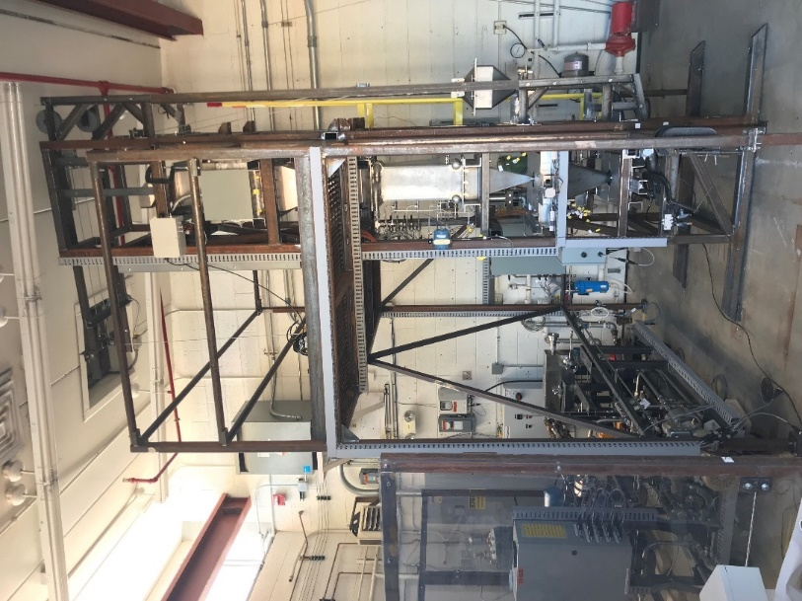
Figure 7: 775 °C Particle Recirculation Loop CAD visualization and as-built photo.
The space available for the heat exchanger in the particle flow loop is 40 inches tall, 22 inches wide, and 30 inches deep. The space must accommodate both inlet and outlet hoppers as well as the heat exchanger. Mounting capabilities in the space are flexible, using the customizable steel frame to bolt, rest, or clamp support members in any direction horizontally or vertically.

Instrumentation and Data Collection
The sCO₂ loop is instrumented for measuring temperature, pressure, differential pressure, density, and mass flow rates. Pressure and temperature are measured in all piping segments and at the recuperator, heater, fill system, pump, heat exchanger, and pressure relief valves. Pressure change is always monitored across the installed heat exchanger. Pressure is monitored with differential and steady state pressure transducers. Direct sCO₂ temperatures inside piping and tubing are measured with Resistance Temperature Detectors (RTDs). External surface temperatures are monitored with thermocouples (TCs). Flow and density are measured with two Coriolis flow meters at the outlet of the pump, one measuring flow to the cold loop and one measuring flow to the hot loop and heat exchanger.
On the particle loop, instrumentation includes the weigh hopper for measuring particle flow rate and thermocouples for temperature measurements at all points including in the heater, at the heater outlet, at the heat exchanger inlet, at desired points across the heat exchanger, at the heat exchanger outlet, and in the weigh hopper.
The entire test stand is fully instrumented with temperature readings at over 100 key points, which can be increased or decreased based on test requirements. Appendix A – Sensor Locations and Ranges lists all standard sensors and their measurement type as is typically instrumented in the test loops. Temperature readings at the inlet and outlet of all major components are collected at a minimum. Data is monitored from the adjacent control room. All data is collected and output in an Excel spreadsheet and in text files.

Heat Exchanger Installation
A 22x30x40”(length/depth/height) test area is available for installation of heat exchanger prototypes, including the inlet and outlet hoppers. Sufficient length for the outlet hopper should be considered to meet flow requirements of a specific unit. Typical heat exchanger installations are 20-25” tall, with 15-20” for hoppers, though hoppers can be as short as a few inches tall so long as the height accommodates desired flow requirements. Heat exchangers are typically mounted on support frames custom-built at Sandia, which are integrated into the test stand.
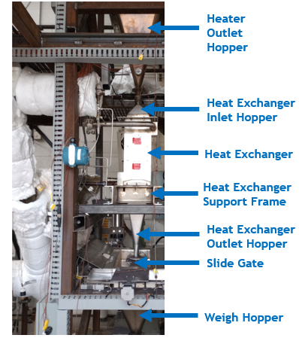
Figure 8: Heat Exchanger Installation in Test Stand
Inlet and outlet hoppers must be designed for the specific heat exchanger unit. Sandia National Labs can design and fabricate these units, or they may be provided or integrated into the heat exchanger. A variety of hopper designs can be supported. In a standard packed-bed design, the inlet of the top hopper is a 1” pipe segment without any flanges, simply installed as a concentric slip joint around the outlet of the particle heater. The outlet of the bottom hopper is typically a 1.5” diameter pipe, to be fixed with a flange supplied by Sandia for connection to the slide gate.
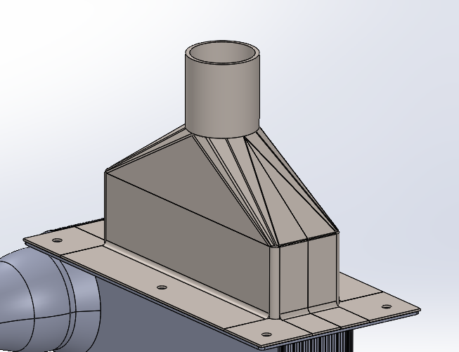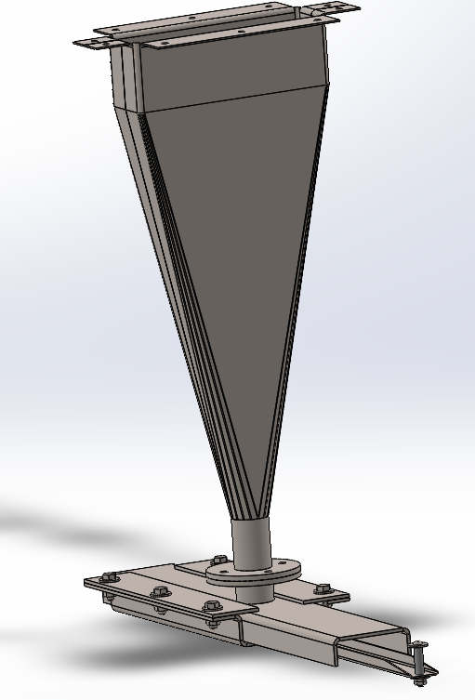
Figure 9: CAD of standard moving packed bed inlet and outlet hoppers mounted to heat exchanger and slide gate
A variety of heat exchanger sCO₂ inlet and outlet header designs can be supported. For each installation, new inlet and outlet tube branches are routed from the sCO₂ loop to the heat exchanger to match specific heat exchanger geometry. This allows for accommodating a range of header spacings and heat exchanger designs. Pipe connections can be made with Grayloc, Swagelok, threaded NPT, welded, ANSI flange, or other connection methods. However, all pressurized sCO₂ components must be verified for operating conditions with pressure testing. Sandia National Labs can assist with determination of appropriate testing methods and acceptance criteria. For low temperature units below 500 ⁰C, 1” SS 316 Swagelok fittings are recommended. For high temperature units operating above 500 ⁰C, 1GR7 SS 316 Grayloc flanges with Inconel 718 seal rings are recommended. Appendix B – Drawings and Diagrams provides more detailed drawings and images of the available space for heat exchanger placement.
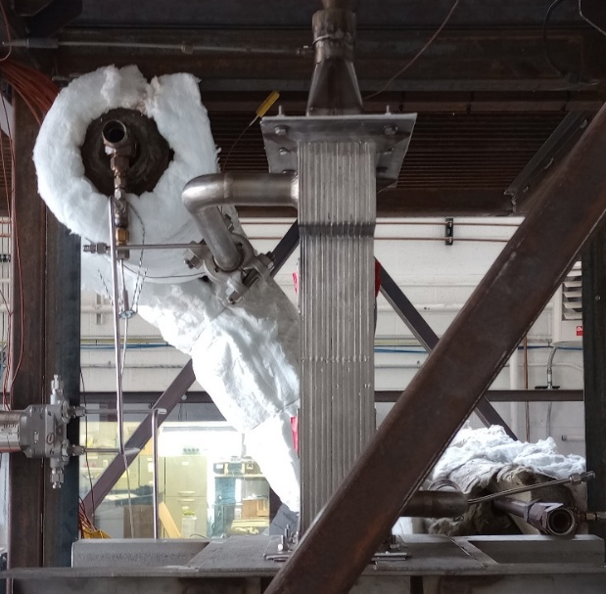
Figure 10: Heat Exchanger on Support Frame Prior to Routing and Connecting sCO₂ Inlet/Outlet Branches
Table 3: Heat Exchanger Inlet and Outlet Connections
 | Inlet | Outlet
Heat Exchanger Particle Side | Inlet hopper of heat exchanger – specific design, with 1” pipe inlet for slip joint connection to particle heater outlet. | Outlet hopper of heat exchanger – specific design, with 1-1.5” pipe outlet for connection to slide gate.
Heat Exchanger sCO₂ Side | ¾” to 1 ¼” pipe/tube connection or flange rated for 2500 psig (17 MPa). Grayloc preferred for 500 ⁰C or above, Swagelok preferred for below 500 ⁰C. | ¾” to 1 ½” pipe/tube connection or flange rated for 2500 psig (17 MPa). Grayloc preferred for 500 ⁰C or above, Swagelok preferred for below 500 ⁰C.

Start-Up, Operation, and Shut Down Procedures
The system is filled with liquid CO₂ using 250 ft³ K-type siphon tube bottles at 600 psig (4.1 MPa). A single stage, double acting gas booster with a 20:1 compression ratio is used to increase the system pressure to supercritical conditions. The supercritical point varies with atmospheric conditions and system temperatures, but generally supercritical CO₂ conditions occur at 31 °C and 1071 psig (7.4 MPa). Density is used as the determining factor for having reached ideal supercritical conditions. The pump cannot be operated until sCO₂ density is above 830 kg/m³, and during startup the pump will not be initiated until 850 kg/m³. Once the pump is running, glycol coolers and chillers remove heat from compression while continuing to fill with CO₂. When system pressures reach >1500 psig (10.3 MPa), sCO₂ density is typically above 900 kg/m³ and the system is ready for heating.
Careful balancing of pressure, temperature, and density is required to protect system components such as the pump. While operation as low as 1160 psig (8.0 MPa) is possible, it is very challenging to increase the sCO₂ temperature while simultaneously venting excess pressure and maintaining density at the pump limit of 830 kg/m³. Therefore, potential system users should consult with Sandia operators regarding realistic combinations of temperature and pressure.
Heating is first performed with the sCO₂ heater prior to circulating any particles, to avoid thermal shock from pockets of high temperature particles if testing was recently conducted. sCO₂ temperatures will be ramped to a minimum of 100 ⁰C before circulation and heating of particles. If multiple flow rates are required on a given test day, heating and operation will begin at the lowest flow rate. Particle flow is only increased in large increments throughout a test day, never lowered. This is to protect the particle heater, as lowering particle flow rate in large increments while operating the heater creates a risk of rapid temperature increase if heater power is not immediately lowered concurrently.

Operating Costs
Operating costs vary greatly with test plan, heat exchanger design, and required prep work. Standard costs include single use and custom fabricated components such as CO₂ bottles, Swagelok tubing, Swagelok fittings, insulation, and gaskets. Additional costs may be custom fabricated components such as support frames or hoppers. A 10% project fee is required by Sandia National Laboratories. A daily facility operation fee of $250 is required but waived for DOE CMEI funded projects. Finally, hourly labor costs for Sandia personnel are required.

Appendix A – Sensor Locations and Ranges
Table 4: Heat exchanger test stand instrumentation. The table below lists the standard sensors used in operation and data collection for the particle and sCO₂ flow loops. All measurement fields record at all times data recording is active. Frequency of data recording is customizable from 0.1-1 Hz
Field | Measurement | Units
Time | Time of sample recording | Seconds
1.5 hp Pump Frequency Command | Pump operating frequency | Hz
Particle Heater Enable | Particle heater on/off | N/A
Particle Heater Power Command | Particle heater outlet power | %
Particle Heater Power Feedback | Particle heater outlet power | kW
CO2 Heater Enable | CO2 heater on/off | N/A
CO2 Heater Power Command | CO2 heater outlet power | %
CO2 Heater Power Fdb | CO2 heater outlet power | kW
CO2 Heater Cartridge Temperature 1 | Temperature | °C
CO2 Heater Cartridge Temperature 2 | Temperature | °C
CO2 Heater Cartridge Temperature 3 | Temperature | °C
CO2 Heater Cartridge Temperature 4 | Temperature | °C
CO2 Heater Outlet Temperature | Temperature | °C
Recirc Valve Position Command | Recirculation valve open position | %
Flow Valve Position Command | Flow valve open position | %
Bypass Valve Position Command | Bypass valve open position | %
Mixing Valve Position Command | Mixing valve open position | %
CO2 Inlet Heat Trace Enable | CO2 heat trace on/off | N/A
CO2 Outlet Heat Trace Enable | CO2 heat trace on/off | N/A
CO2 Heat Trace Inlet Power Command | CO2 heat trace power outlet | %
CO2 Heat Trace Outlet Power Command | CO2 heat trace power outlet | %
1.5 hp Pump Enable | Pump on/off | N/A
Drive Air Enable | Drive air on/off | N/A
Open Trim Valve | Trim vent valve open | N/A
Open Vent Valve | Primary vent valve open | N/A
Open Fill Valve | Fill valve open | N/A
Weigh Hopper Command | Weigh hopper activation | N/A
Particle Lift Command | Skip hoist activation | N/A
Particle Heater Inlet Temperature | Temperature | °C
Particle Heater Outlet 1 Temperature | Temperature | °C
Particle Heater Outlet 2 Temperature | Temperature | °C
Particle Heater Outlet 3 Temperature | Temperature | °C
Particle Heater Outlet 4 Temperature | Temperature | °C
Particle Heater Outlet 5 Temperature | Temperature | °C
Particle Heater Outlet 6 Temperature | Temperature | °C
Particle Heat Exchanger Inlet 1 Temperature | Temperature | °C
Particle Heat Exchanger Inlet 2 Temperature | Temperature | °C
Particle Heat Exchanger Inlet 3 Temperature | Temperature | °C
Particle Heat Exchanger Outlet 1 Temperature | Temperature | °C
Particle Heat Exchanger Outlet 2 Temperature | Temperature | °C
Particle Heat Exchanger Outlet 3 Temperature | Temperature | °C
Particle Weigh Hopper Outlet Temperature | Temperature | °C
Particle Catch Hopper Outlet Temperature | Temperature | °C
Particle Lift Inlet Temperature | Temperature | °C
Ambient Temperature | Temperature | °C
CO2 Pump Outlet Temperature | Temperature | °C
CO2 Recuperator Cold Inlet Temperature | Temperature | °C
CO2 Recuperator Cold Outlet Temperature | Temperature | °C
CO2 Heat Exchanger Inlet Temperature | Temperature | °C
CO2 Heat Exchanger Outlet Temperature | Temperature | °C
CO2 Recuperator Hot Inlet Temperature | Temperature | °C
CO2 Recuperator Hot Outlet Temperature | Temperature | °C
CO2 Cooler Outlet Temperature | Temperature | °C
CO2 Pump Inlet Temperature | Temperature | °C
Glycol Cooler Inlet Temperature | Temperature | °C
Glycol Cooler Outlet Temperature | Temperature | °C
Glycol Chiller Inlet Temperature | Temperature | °C
Glycol Chiller Outlet Temperature | Temperature | °C
CO2 Chiller Inlet Temperature | Temperature | °C
CO2 Cooler Inlet Temperature | Temperature | °C
CO2 Pump Differential Pressure | Pressure | psig
CO2 Heat Exchanger Differential Pressure | Pressure | psig
CO2 Heat Exchanger Pressure | Pressure | psig
CO2 Recuperator Cold Differential Pressure | Pressure | psig
CO2 Recuperator Hot Differential Pressure | Pressure | psig
CO2 Pump Outlet Pressure | Pressure | psig
CO2 Cylinder Pressure | Pressure | psig
Air Pressure | Pressure | psig
CO2 Recirculation Flow Rate | CO2 flow rate | kg/s
CO2 Recirculation Density | CO2 density | kg/m3
CO2 Recuperator Flow Rate | CO2 flow rate | kg/s
CO2 Recuperator Density | CO2 density | kg/m3
Glycol Cooler Flow Rate | Glycol flow rate | gpm
Glycol Chiller Flow Rate | Glycol flow rate | gpm
Particle Load Cell | Load cell mass | kg
Particle Feed Hopper Left-Top-Left Temperature | Temperature | °C
Particle Feed Hopper Left-Top-Right Temperature | Temperature | °C
Particle Feed Hopper Left-Bottom Temperature | Temperature | °C
Particle Feed Hopper Right-Top-Left Temperature | Temperature | °C
Particle Feed Hopper Right-Top-Right Temperature | Temperature | °C
Particle Feed Hopper Right-Bottom Temperature | Temperature | °C
Open K Type Thermocouple 1 | Temperature | °C
Open K Type Thermocouple 2 | Temperature | °C
Open K Type Thermocouple 3 | Temperature | °C
Open K Type Thermocouple 4 | Temperature | °C
Open K Type Thermocouple 5 | Temperature | °C
Open K Type Thermocouple 6 | Temperature | °C
Open K Type Thermocouple 7 | Temperature | °C
Open K Type Thermocouple 8 | Temperature | °C
Open K Type Thermocouple 9 | Temperature | °C
Open K Type Thermocouple 10 | Temperature | °C
Open K Type Thermocouple 11 | Temperature | °C
Open K Type Thermocouple 12 | Temperature | °C
Open K Type Thermocouple 13 | Temperature | °C
Open K Type Thermocouple 14 | Temperature | °C
Open K Type Thermocouple 15 | Temperature | °C
Open K Type Thermocouple 16 | Temperature | °C
Open K Type Thermocouple 17 | Temperature | °C
Particle Outlet Hopper Front-Left Temperature | Temperature | °C
Particle Outlet Hopper Front-Middle Temperature | Temperature | °C
Particle Outlet Hopper Front-Right Temperature | Temperature | °C
Particle Outlet Hopper Side-Left Temperature | Temperature | °C
Particle Outlet Hopper Side-Middle Temperature | Temperature | °C
Particle Outlet Hopper Side-Right Temperature | Temperature | °C
Particle Outlet Hopper Top Temperature | Temperature | °C
Particle Outlet Hopper Bottom Temperature | Temperature | °C
Open M8 Connection 1 | Pressure, flow, other sensors | N/A
Open M8 Connection 2 | Pressure, flow, other sensors | N/A
Open M8 Connection 3 | Pressure, flow, other sensors | N/A
Open M8 Connection 4 | Pressure, flow, other sensors | N/A
Open M8 Connection 5 | Pressure, flow, other sensors | N/A
Open M8 Connection 6 | Pressure, flow, other sensors | N/A
Open M8 Connection 7 | Pressure, flow, other sensors | N/A
Open M8 Connection 8 | Pressure, flow, other sensors | N/A
Open M8 Connection 9 | Pressure, flow, other sensors | N/A
Open M8 Connection 10 | Pressure, flow, other sensors | N/A
Open M8 Connection 11 | Pressure, flow, other sensors | N/A
Open M8 Connection 12 | Pressure, flow, other sensors | N/A
Open M8 Connection 13 | Pressure, flow, other sensors | N/A
Open M8 Connection 14 | Pressure, flow, other sensors | N/A
Open M8 Connection 15 | Pressure, flow, other sensors | N/A
Open M8 Connection 16 | Pressure, flow, other sensors | N/A
Open M8 Connection 17 | Pressure, flow, other sensors | N/A
Open M8 Connection 18 | Pressure, flow, other sensors | N/A
Outlet Slide Gate Enable | Slide gate on/off | N/A
Outlet Slide Gate Position Fdb | Slide gate linear actuator position | mm
Air Flow Enable | Air flow on/off | N/A
Air Flow Cmd | Air flow rate | slpm
Air Heater Enable | Air heater on/off | N/A
Air Heater Temperature Cmd | Temperature | °C
Air Heater Temperature | Temperature | °C

Appendix B – Drawings and Diagrams
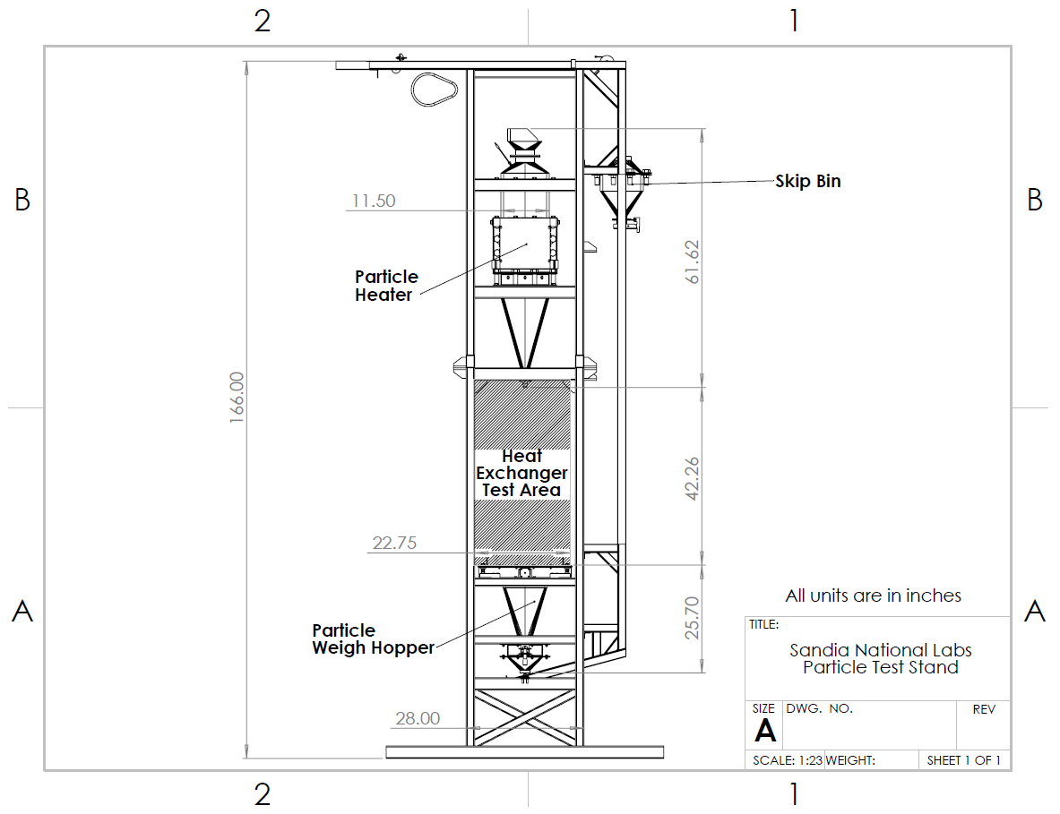
Figure 11: Particle Heat Exchanger Test Stand with Heat Exchanger Test Area – Side View

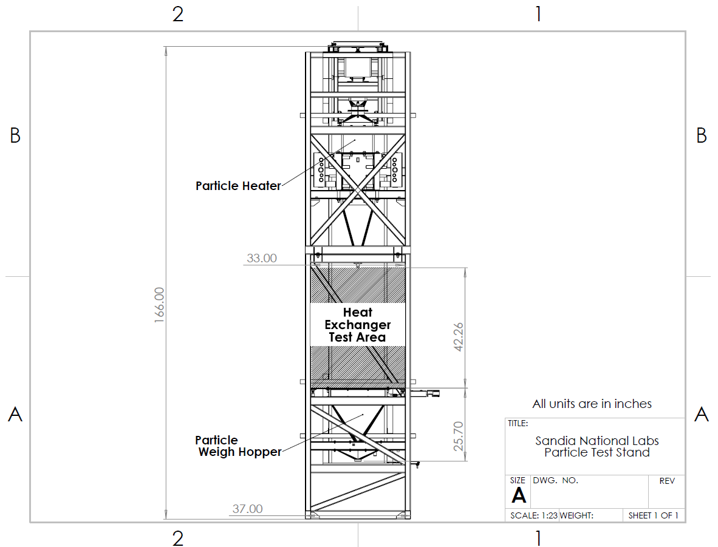
Figure 11: Particle Heat Exchanger Test Stand with Heat Exchanger Test Area – Front View

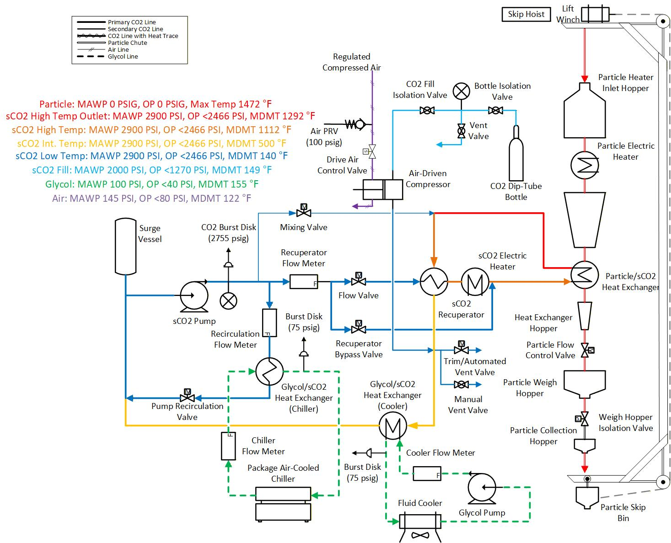
Figure 11: Particle/sCO₂ Heat Exchanger Test System P&ID

