Establishment of Grid Modernization Laboratory Consortium – Testing Network

The U.S. Department of Energy launched the GMLC in November 2014. The consortium, a strategic partnership between DOE headquarters and the national laboratories, brings together leading experts and resources to collaborate on national grid modernization goals. The GMLC’s work is focused in **six technical areas** viewed as essential to modernization efforts:

* Devices and Integration
* Sensing and Measurement
* Systems Operations, Power Flow and Control
* Design and Planning
* Security and Resilience
* Institutional Support

**CHALLENGE**

The electric power grid is a complex system comprising a range of interconnected and rapidly evolving technologies, e.g., generation, storage, delivery, and loads. These systems are being called upon to execute increasingly complex activities such as advanced grid support capabilities, communications-based distributed controls, interoperability, and cyber-security. Testing and validation resources for these emerging grid technologies are not readily available, and those that are available exist across many organizations and lack an overarching coordination framework and a central information repository. Enabling access to a comprehensive testing infrastructure and creating a repository of models and simulation tools can help facilitate and accelerate grid modernization by making data and transferable models available, supporting validation and standardization, and reducing duplication of effort.

**KEY OUTCOMES**

This effort will accelerate grid modernization and the development, validation, standardization, adoption, and deployment of new grid technologies by enabling access to a comprehensive testing infrastructure and creating a repository of models and simulation tools. This project will also enable national laboratories to drive innovation more effectively and synergistically. There are two key outcomes that encompass these results:

* ***Establishment of a Grid Modernization Laboratory Consortium Testing Network*** that will function as a coordinated lab-based resource for standards-based testing and validation of grid devices and systems. Results include the creation of a catalog of testing capabilities available at national laboratories, universities, utilities, and other industry groups, as well as a roadmap document identifying opportunities for strategic investment in testing capabilities.
* ***Development and implementation of a*** ***Grid Modernization Laboratory Consortium – Open Library*** to serve as a public repository for component models, simulation tools, and testing resources.

**BENEFITS**

By providing access to and data about testing and validation capabilities, this project will support all three major objectives of the Grid Modernization Multi-Year Plan: reduction in the economic costs of power outages, decrease in cost of reserve margins while maintaining reliability, and decrease in the net integration costs of distributed energy resources. It will also support other foundational GMLC activities, including regional demonstrations, by providing laboratory-tested validation models and simulation tools. The results will be an integrated, readily available environment for grid modernization, interconnection, and interoperability test efforts. This work leverages related research by DOE, the U.S. Department of Defense, and academia.

The cross-functional team involved in this project offers the technical, analytical, and strategic capabilities vital to the work’s success. The participation of researchers from 10 national laboratories provides access to expertise across a broad skill base, including power system planning, grid integration, power electronics, codes and standards, communication and control systems, microgrids, modeling, and cybersecurity. The laboratory team is strategically partnered with academia, industry, industry consortia, and non-profits to ensure broad stakeholder engagement and practicable solutions that meet industry needs for advancing grid modernization.

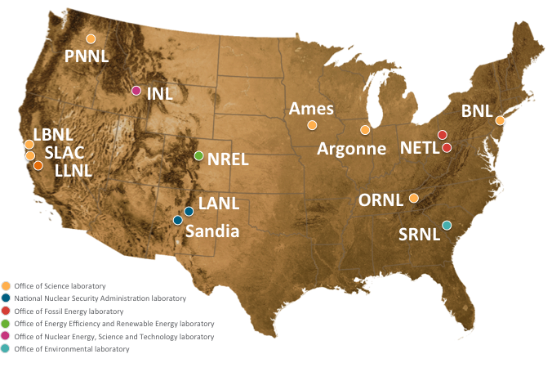

**Contact**

Benjamin Kroposki

National Renewable Energy Laboratory

Benjamin.Kroposki@nrel.gov

(303) 275-2979

**Contact**

Abraham Ellis

Sandia national Laboratories

[aellis@sandia.gov](mailto:aellis@sandia.gov)

(505) 844-7717